160 Items from stock

Items from stock

John Turton Antiquarian Books
1-2, Cochrane Terrace, Willington, Crook, Co Durham, DL15 0HN

telephone: +44 (0)1388 745770
fax: +44 (0)1388 746741
e-mail: johnturton@turtome.co.uk

Payments may be made by sterling cheque, credit or debit card (not Amex or Diners Club), direct payment to our bank account, or non-sterling drafts and cheques by arrangement.

Postage, and insurance if required, is extra. Within the UK items are sent first class or by 48 hour tracked parcel; overseas by airmail.

Any item not as described may be returned within 7 days. Please let us know of this prior to despatch.

All prices are net.

Usual terms and conditions regarding payment apply for libraries and institutions.

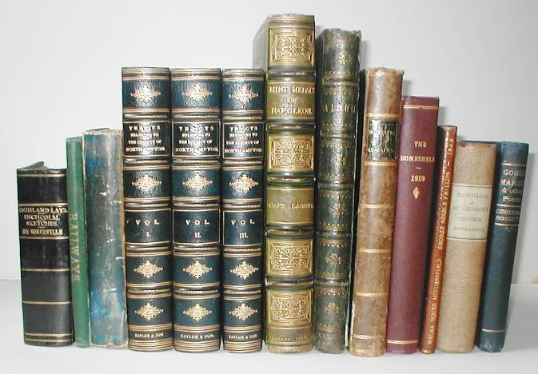

VAT No. 389 6138 01

1 The Life of Richard Turpin, the notorious highwayman, containing an account of his bold adventures, daring robberies, his expertness in horse-stealing; also his trial, execution, &. Newcastle: printed and sold by W. and T. Fordyce, 15, Grey Street, N.D.
17cm. 24pp, title page vignette. £45
Hunt gives W and T Fordyce’s dates at 15 Grey Street as 1841-1844.
COPAC: Oxford, Birmingham, NLS, and Durham for this precise edition. OCLC adds Sterling Memorial Library, Yale.

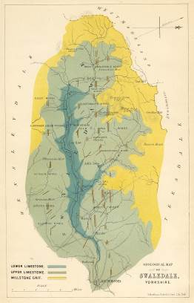
2 BRADLEY, Lonsdale. An inquiry into the deposition of lead ore in the mineral veins of Swaledale, Yorkshire. London: Edward Stanford, 1862.
Large 8vo. vii[i], 40pp, colour-printed geological map frontis, [2]pp, hand-coloured reference plate, suite of 10 colour-printed and part hand-coloured plates at rear, text tables. Original blind-stamped blue grained-cloth gilt, yellow endpapers. Extremes rubbed with light wear; small neat repairs to spine tips. £240
Lonsdale occasionally contributed to geological periodicals. His other major work was on artificial manures.
Not in Challinor.

3 CHARRIER, J. Samuel. A chorographical description of the fifty-two counties of England and Wales, placed alphabetically, designed for the use of noblemen, gentlemen, merchants, travellers, traders, and all other curious persons. Humbly inscribed to his Royal Highness George Prince of Wales. London: Printed for the author by J. and W. Oliver, N.D. (c.1772).
4to. [38]pp. Recent blue paper wraps, stab-sewn. Text age-browned. £175
A gazetteer type publication in tabular form. Details of each county are entered into one of ten headed columns providing an immediate overview and brief history.
ESTC: L, E, NT, AWu. OCLC adds the Universities of Cornell, Delaware, Minnesota. Not in Cox.

4 The complete florist: or, the lady and gentleman's recreation in the flower garden; being a choice compendium of what hath been worthy notice for the propagation, raising, planting, encreasing, and preserving the rarest flowers and plants. Wherein each flower is so particularly described, as none can be at a loss to know the contents of the flower garden. With full directions for managing the different sorts of auricula's, anemonies, narcissus's, hyacinths, tulips, and all bulbous roots. Together with directions what to do each month in the year. London: printed for R. Snagg and J. French, N.D.
12mo in sixes. iv, 156pp, copper-plate frontis, full-page text table. Contemporary marbled sides with later sprinkled calf re-back and endpapers, red calf gilt spine label. Boards rubbed with light wear; small closed tear to frontis fore-edge not into image; light off-set from frontis to title page. £380
A second edition, in two issues, was published c.1785.
ESTC: L, Lke. Nothing added in COPAC or OCLC. Date assigned is 1775? No copy of the 1st edition at the Lindley Library.
Blanche Henrey 572.

5 [STALEY, Finetta.] Autumn Rambles; or, fireside recollections of Belgium, the Rhine, the Moselle, German spas, Switzerland, the Italian lakes, Mont Blanc, and Paris. Written by a lady, for private circulation in aid of the Rochdale Relief Fund. Published by subscription. Rochdale: printed by E. Wrigley and Son, 1863.

8vo. vii[i], 217[1]pp. Original decorated blind-stamped green grained-cloth gilt, yellow endpapers, all edges gilt. £125
Title to spine ‘Autumn rambles upon the continent in 1862’.The relief fund referred to in the long title was part of the larger movement throughout Lancashire addressing the problems within the cotton trade.
COPAC: BM, NLS, BOD. Global Odyssey: a bibliography of travel literature before 1940, page 201. Not in Rochdale Local Studies catalogue on-line.

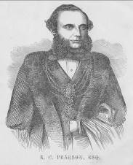
6 SMITH, James (Editor). Proceedings relative to the Pearson’s Park, from its earliest commencement to the time of its free gift by Zachariah Charles Pearson, Esq., Mayor, to the people of Hull. Hull: Yorkshire Printing and Publishing Co, 1860.
8vo in fours. 48pp, portrait frontis with tissue-guard, title page device, decorated capital. Original navy moire-patterned limp-cloth gilt, patterned endpapers. Spine and part of boards browned; margins slightly age-browned. £90
COPAC: BL, York Minster.

7 PROSPECTUS. Prospectus of a new miscellany, to be published on the 1st day of February, 1800, (price eighteen-pence) and to be continued monthly, entitled The British Magazine, consisting of original communications in history, philosophy, belles lettres, politics; the arts, sciences, amusements, &. In addition to which will be given an ample and interesting detail of public events, provincial occurrences, and other subjects of general importance. London: printed by T. Davison, [1799.]
22cm. 4pp. caption title. Stab-holes to gutter-margin; light spotting; fore-edge margins chipped without affecting text. £75
Presumably the British Magazine, as listed in BUCOP, which ran from January 1800 to January 1801.
ESTC: L, O; GOT.

8 PROSPECTUS. A magazine for youth of both sexes. To parents, governesses, and schoolmasters. On Friday, February 1, 1799, will be published, ... Number I. ... of the Young gentleman’s and lady’s magazine; or universal repository of knowledge, ... [London, 1798.]
22cm. [2]pp. caption title. Stab-holes to gutter-margin; light spotting. £50
‘12 monthly parts were issued, the last in January 1800.’
ESTC: L; GOT. Roscoe (J393)

9 SKINNER AND CO., Auctioneers. Particulars of the capital freehold estate...in the parish of Felton...comprising the extensive manor or lordship of Eshott, in Northumberland. [London: printed for Skinner and Co, 1785.]
Docket title. Printed on the two inner pages of a bifolium. Folded for the post. Light soiling to external folds; small closed tear to one external fold - not into text. ‘M. Adams, Alnwick’ in manuscript. beneath the docket title - presumably the same Adams mentioned, among others, at the foot of page [2] ‘of whom printed Particulars may be had’. £225
The Eshott estate was purchased by William Carr in 1588 and was still in the family’s possession at the time of this sale (‘The Estate is subject to an Annuity of 100l. payable to Mrs Jane Carr, of Barbadoes, aged 56 Years.’)
Mr. [Thomas] Adams of Alnwick (see above) bought the estate for £34,000 in 1792, when the Carr dynasty collapsed.
Not in ESTC.
Thomas Skinner of Aldersgate Street held regular sales in Change Alley during the last two decades of the eighteenth century. His sale of the contents of the Portland Museum in 1786 extended over 37 days.

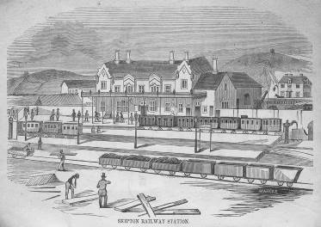
10 [BAILEY, Benson.] Views from the North Western, or descriptions of the principal objects of attraction, to be seen in the rural district between Skipton and Morecambe Bay. Bingley: John Harrison and Son, 1852.
8vo. 50[2]pp including wraps, text illustrations (some full-page), head and tail-pieces, decorated capitals. Original decorated printed card wraps, view to inner front wrap. Wraps soiled and lightly rubbed. £140
With five full-page woodcut views within the pagination and vignette text illustrations by, or in the style of, Bewick.
COPAC: York Minster. Not in Ottley.

11 The patent elastic chest expander, for the prevention and removal of stooping of the shoulders and contraction of the chest in young persons and ladies and gentlemen of all ages. Manufactured and sold only by Alfred Binyon, London. London: printed by J. Carrall, c.1850.
20cm. 4pp, text illustrations. Remnants of blue paper to gutter margin of title page. £30
Not in NSTC. COPAC adds the V & A, but with a different heading.

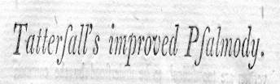
12 PSALMODY IMPROVED. Tattersall’s improved psalmody. This day is published, Merrick’s Psalms, divided into stanzas, bound in calf ... Testimonies already published in favour of Improved psalmody. N.P., N.D.
22cm. 4pp. drop-head title. Stab-holes to gutter-margin. £50
A price list of texts, music, and the sermons relating to them.
ESTC: L, O; GOT. ESTC gives the date as [1795?] , confirmed by the pamphlet’s contents. The Gottingen copy is bound with the Gentlemans’ Magazine for 1799.

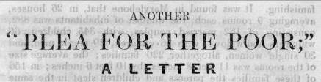
13 PLEA FOR THE POOR. Another “Plea for the Poor;” a letter addressed to Christians of all denominations, on the condition of the people, and the only effectual remedy. By an evangelical reformer. [Ipswich: printed for the author and sold by J. Scoggins. London: sold by M. and S. Higham,] N.D.
18cm. 16pp, text tables, caption title. Very slight isolated spotting; light age-browning. £120
Part of the debate taking place in the early 1840’s on the effect of the Corn laws on the poor.
Copsey 938 giving the author as John Glyde and a date of 1843? NSTC lists A plea for the poor written by Baptist W. Noel in 1841; this is well held as an electronic resource in academic libraries. During 1840 Noel had conducted an inquiry into the condition of English elementary schools in Birmingham, Manchester, Liverpool and elsewhere.

PAWNBROKING AND AUCTIONEERING AROUND TYNESIDE
14 Auction sale-book. Bolton: Tillotson and Son, pawnbrokers’ printers, N.D.
33cm. Unpaginated 5-column ruled account book, printed in red and black, each page with a printed heading ‘Sale book of pledges for loans of above ten shillings.’ followed by further printed details. Original linen-backed marbled card wraps, printed paper label to front wrap. Wraps rubbed and worn with tears and loss to front wrap; closed tears to the lower part of the first few leaves with old tape repairs to the first leaf. Printer’s details from the label to front wrap. £240
A pawnbroker’s pledge book for the period 1874 to 1907. Kept initially by W. R. Rennison of 186 Linskill Street, North Shields, the business was taken over by Thomas Driver c.1877 and (his son?) George Thomas Driver c.1887. Details include the number of the pledge, amount of loan, and sum which the pledge sold for as stated by the Auctioneer. Some additional material is inserted, principally itemised receipts from auctioneers (some on headed notepaper), roup rolls, and printed details of sales particulars. Towards the end of the volume are two fine large-format advertising sheets for the sale of unredeemed pledges in 1903 and high pledges in 1904. Both these sales were conducted by Bainbridge and Son, Driver’s preferred auctioneer from c.1902. Prior to this, other local auctioneers were employed, namely: Charles A. Joel of Pilgrim St, Newcastle; Mr Aitcheson of North Shields; Coats Bros. of Camden St., North Shields and John Gray of Wylam St., Jarrow.
As may be expected clothing and general household goods feature prominently in the lists; clocks and watches are given special treatment in their own sales. Overall the auction prices attained were below the ‘amount of loan’.

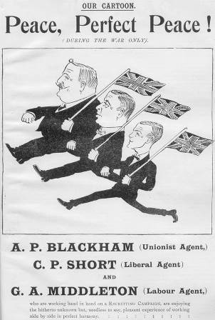
15 Our Flag. [Comprising Vol. X issues 1-9 for Jan-Sept 1914 and 12 issues of the same title, with the sub-title ‘The Unionist magazine for the north-east division of Derbyshire.’ for the 12 months of 1914 and printed on superior paper.] [London: National Unionist Association of Conservative and Liberal Unionist Organisations,] 1914.
30cm. 146[1]pp plus unpaginated issues of the sub-titled production, colour plus black/white plates, text illustrations. Publisher’s decorated half calf, grained blue-cloth sides gilt, marbled endpapers. Re-spined with plain cloth; corners rubbed; age browning to the ‘Our Flag’ issues; piece torn away from the fore-edge margin of advert leaf 47/48 without affecting text. £95
Previously known as The Conservative (Jan 1905 - Oct 1907) then The Conservative and Unionist (Nov 1907 - May 1912) Our Flag commenced in June 1912 and ended in December 1914. These 8 page issues cover local political problems and provide significant local historical information. The October, November and December copies strongly promote recruitment for the War and include Rolls of Honour and Obituaries.
Although BUCOP and COPAC locate runs at the British Library and the Bodleian, the regional issue is not located.
16 KUKLOS; Peter ELAND (Editors). The Bradford Jackdaw. April 14, 1904 - April 6, 1905 (2 Vols - all published). [Comprising 52 issues.] [Bradford: Percy Lund, Humphries and Co,] 1904-5.
24cm. Various pagings, text illustrations, adverts, printed in double columns. Contemporary half maroon calf gilt, raised bands, decorated compartments, black calf gilt spine labels, matching grained-cloth sides, sprinkled leaf-edges. Extremes lightly rubbed; light spotting to end papers. £280
Much of local sporting interest; also theatre, politics and the Bradford Exhibition.
Not in NSTC III or BUCOP. (SOLD)

17 POINTER, John. Britannia Romana, or Roman antiquities in Britain, Viz. Coins, camps, and publick roads. Being a full account and explanation of the Roman coins found in Britain at different places and divers times, ... Also a large preface, shewing the usefulness of ancient coins and medals, in relation to history, poetry, sculpture, painting, and architecture... Oxford: Printed by Leon Lichfield, 1724.
12mo in sixes, [xx], 55[5]pp, multi-folding map, issue with page 15 unsigned and page 35 signed E2, pp.9-12 misbound after page16. Contemporary half vellum, marbled paper sides, later endpapers. Vellum discoloured; text age-browned; minor foxing to endpapers; small hole in title page fore-edge margin where name has been erased, no loss of lettering. £200
Cox page.446 noting Gough's contempt for the work - "his pompous title page produces nothing".

Christopher and Jennet(t) were a significant printing firm in Stockton during the late eighteenth and early nineteenth centuries. Robert Christopher produced the standard antiquarian work on Stockton in 1796; while not included in the imprint of Brewster’s History ... it would appear that Thomas Jennett, formerly Christopher’s apprentice, became a partner in the firm the previous year. The two worked together until Christopher’s death in 1819.
The material offered below, typical of a more-than-competent provincial outfit, exhibits a distinct typographical awareness and style.
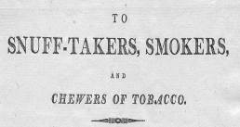
18 SNUFF AND TOBACCO. To snuff-takers, smokers, and chewers of tobacco. Stockton: printed by Christopher and Jennett, (c.1805).
Broadside 252 x 185mm. Two horizontal folds. £95
Contains references to Sir John Pringle, Dr. Franklin, Dr. Rush and [George] Washington.

19 BREWSTER, John. A farewell address to the inhabitants of the parish of Stockton upon Tees on resigning the vicarage of that place. Stockton: printed by Christopher and Jennett, 1805.
8vo in fours. 16pp. £150
Brewster resigned the living on July 11 and moved to Redmarshall. To mark the occasion he was presented with a cup valued at 100 guineas. His ministry in Stockton began in 1776.
Not in COPAC, NSTC, OCLC or Durham University catalogue online.

20 Form of prayer, for the use of Sunday Schools. Stockton: printed by Christopher and Jennett, N.D.
19cm. 8pp, head and tail-piece. £250
Not in COPAC, NSTC, OCLC or Durham University catalogue online.

21 TRAFALGAR SERMON. A sermon, preached on the 5th December, 1805, being the day appointed for a general thanksgiving, on account of victory over the combined fleets of France and Spain, off Cape Trafalgar. Stockton: printed by Christopher and Jennett, 1806.
21cm. 15pp, head-piece. £80
One of the numerous ‘Thanksgiving Sermons’ preached on this day. A pencil note on the title page gives the author as the Rev. J. Kennedy.
Not in COPAC, NSTC, OCLC or Durham University catalogue online.

PRIZE PIG – VALUE THREE GUINEAS

22 HUSTLER, Thomas. Premiums and Rewards offered by Thomas Hustler, Esq. to his Tenants and Cottagers. 1806. Stockton: printed by Christopher and Jennet, 1806.
Broadside 410 x 259mm. Horizontal and vertical creases; small isolated browned areas; contemporary ink title to verso. £125
The first prize was ‘a silver cup, value five guineas’; however item 7 deserves a full transcription ‘To the Cottager or Day-Labourer (having a Settlement in the Parish of Acklam or in the Township of Linthorpe) who shall have brought up, and educated in Habits of Industry, the greatest Number of legitimate Children with the least Parochial Relief, - A Pig, value Three Guineas.’

23 BREWSTER, John. A thanksgiving sermon for the peace: preached in the parish church of Stockton upon Tees, June 1, 1802, ... Published by request. Stockton: printed by Christopher and Jennett: sold by F. and C. Rivington and W. Clarke, London, 1802.
8vo in fours. [3], 8-27[1]pp. £55
Preached to celebrate the Treaty of Amiens in March 1802.
COPAC: BL, Durham. OCLC adds Universities of Missouri and Yale.

24 BARRINGTON VERSUS STOCKDALE.Postscript of a letter to the Rev. Percival Stockdale, vicar of Lesbury, and Longhoughton, in the county of Northumberland: in consequence of his late letter, addressed to the ... Lord Bishop of Durham, &c. The postscript in reply to The Rev. Mr Stockdale’s late address to the public. Stockton: printed by Christopher and Jennett, [1799].
£420
Arthur Sherbo’s contribution on Stockdale in ODNB gives scant coverage beyond 1790; indeed the period to 1809 is summarised thus: ‘he wrote on a number of subjects, published some sermons, and brought his writing career to an end with two works, Lectures on the Truly Eminent Poets (1807) and ... Memoirs on the life and writings of Percival Stockdale ... (2 Vols. 1809).
A skirmish by pamphlet between Stockdale and Bishop Barrington did take place in 1792 (probably the reason for the 1792 ascription in ESTC - see below). Hostilities recommenced in 1799 and concluded with this vituperative and pointed attack, most likely sanctioned by the bishop, on both the character and theology of Stockdale.
ESTC: Ct, Ldw giving a date of 1792? COPAC adds Durham University Library with the correct date of 1799.
*********************************************************
YORKSHIRE AUTHOR IN NORTH AMERICA

25 TURNER, J. H[orsfall]. A three months’ tour in the United States and Canada. Being a reproduction of sixteen letters which were published week by week in the “Brighouse Observer.” Brighouse: R. H. Ashworth, N.D. (c.1911) 13cm. 176pp. Original half green calf gilt, matching green cloth sides, spine and front board lettered direct, patterned endpapers. Small neat matching calf repair to spine head; boards lightly soiled; light spotting and soiling to text, ink blot to fore-edge margin of page 121. £300
This was one of JHT’s last works. Only “Our Customary Feasts.” published in 1913 came after it.
No copy found in the BL integrated catalogue, COPAC, OCLC, Leeds Central Library, Bradford Central Library, Sabin, or Evans. The only copy located is that at Halifax Central Library which houses the special collection on Turner.

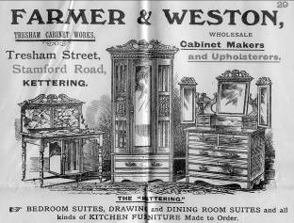
26 New business street map of Kettering. Shewing the ward boundaries in red; with which is annexed and alphabetical street list, and other useful information. Leicester: The Leicester Printing and Publishing Co, [1906].
Multi-folding map (scale: 12 inches to one mile) approx 47 x 34cm. within local adverts - total size 85 x 72cm. printed in red and black. Original printed blue card wraps. Wraps slightly chipped; small tears to map fold intersections. The map dated 1906 in lower margin. £50
The publishers almost certainly the successors to Stephens and Mackintosh.

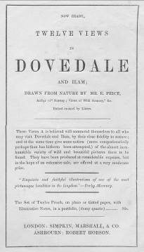
27 [HOBSON, Robert.] Twelve views in Dovedale and Ilam, from drawings by Mr. Edward Price; ... with illustrative notes. Ashbourn: Robert Hobson; London: Simpkin, Marshall, and Co, N.D.
4to. 4pp ‘Notes’, 12 steel-engraved plates. Original decorated green glazed-card gilt portfolio. Covers rubbed and browned. Adverising flyer loosely inserted with contents. £350
Edward Price (1823-1854) was born in Nottingham and became a pupil of J. Glover.
COPAC: Oxford (c.1844), NLS (c.1844), BL (1845?) Notes ascribed to Hobson. OCLC: Yale University Library - date given as [1845?]. Advertising flyer not present.
‘Derbyshire, a select catalogue of books about the county’, page 81, gives the date [1845.]

28 AINSLIE, William. Sixty-six years’ residence in South Africa. An autobiographical sketch. Fort Beaufort Printing and Publishing Co, 1899.
14cm. 138pp, title page with printed decorated border, tail-pieces, decorated capitals. Original unlettered limp green grained-cloth wraps, printed on art-paper. Spine rubbed; small closed tear to front free endpaper fore-edge; occasional light soiling, text offset throughout due to poor quality printing. £240
From the first chapter we learn that the author hailed from the Scottish Borders: his father from Jedburgh; his mother, Kelso. The family settled in Hawick where Ainslie senior worked as a brewer and distiller and later as a bookbinder. Ainslie junior was born c.1816 and was thus well into his eighties when the work was published.
As the preface, by A. Hanesworth, states - ‘Mr. Ainslie’s story [shows] how he and his comrades fared in the Kaffir and Hottentot Revolts of half-a-century ago’. Pages 33-114 deal at length with the war of 1851-2.
Not in COPAC, OCLC, or Mendelssohn. (SOLD)

29 BROUGHTON, Brian. Six picturesque views in North Wales, engraved in aquatinta by Alken, from drawings made on the spot: with poetical reflections on leaving that country. London: printed by J. Mawman by T. Bensley, 1801.
Small fo. 32pp, 6 aquatint plates. Mid-nineteenth century half calf, marbled boards, much later reback with spine lettered direct, new blanks added, sprinkled leaf-edges. Extremes rubbed with light wear; spotting to last text leaf; small hole to last leaf gutter-margin not affecting text; light offset from final plate to ‘Notes’ page. £300
Abbey Scenery 517; Prideaux, page 329 noting the 1798 edition with 4 plates; Cox, page 183 - also the 1798 edition.

LORD PETER WIMSEY DELINEATED

30 WIMSEY, Matthew, pseud. [i.e. Dorothy Leigh SAYERS.] Papers relating to the Family of Wimsey. London: privately printed for the family by Humphrey Milford [at The Westminster Press,] N.D. [1936 limited edition of 500 copies.]
8vo. 55[1]pp, frontis, title page device, plate, full-page text pedigree. Original printed blue card wraps, yapp-edges, housed within a purpose-made fold-over quarter-linen book-box, paper sides lettered as the original. Loosely inserted is a fine ALS, on ‘The Institution of Municipal Engineers’ headed notepaper from C. W. Scott-Giles to Mr [John] Power saying he is glad to inscribe the latter’s copy of the Wimsey Papers. The letter postscript is quoted here-’While my wife and I had something to do with the Wimsey Papers we were not the chief perpetrators - Dorothy Sayers and Helen Simpson were chiefly concerned. CSG’. Both Mr and Mrs Scott-Giles are thanked in the foreword. Wraps partly browned, few small tears to edges. £650
Produced with the help of Wilfred Scott-Giles who contacted Sayers early in 1936 about the coat-of-arms (sable, three mice courant argent, with a domestic cat as crest and two saracens as supporters) which she had invented for the Wimsey family.
Charles Scott-Giles (1893- 1982) wrote extensively on heraldry and was appointed Fitzalan Pursuivant of Arms Extraordinary in 1957 . He worked closely with Sayers on the Wimsey family, especially during the immediate years following the publication of the Wimsey Papers. In 1977 his work ‘The Wimsey Family; a fragmentary history compiled from correspondence with Dorothy L. Sayers’ was published; a second edition appeared in 2007. A scarce item of Wimseyana.
Gilbert A23 ‘About 500 copies were published in December 1936 and distributed to Sayers’ friends as gifts.’

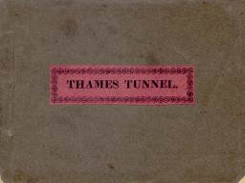
31 THAMES TUNNEL. An explanation of the works of the tunnel under the Thames from Rotherhithe to Wapping. London: W. Warrington, 1839. [41690]
10 x 13cm. 23pp.with 17-23 printed on rectos only, folding panorama, 8 steel engraved plates (3 folding, one with an overslip), and one tinted aquatint plate. Original grey card wraps, original pink paper label, printed ‘Thames Tunnel’ within a decorated border, to front wrap. Spine rubbed with wear; light offset. £280
The Triumphant Bore 69 recording an issue of May 1839; this September issue not recorded but with contents, apparently, as its predecessor. Cohen ‘The Thames’ pp319-320 ‘, detailing editions up to 1829.

32 R. ROBINSON and COMPANY LTD., Clavering Place and St. Nicholas Buildings, Newcastle-on-Tyne. 1818-1918. One hundred years of progress and development. [Newcastle-on-Tyne: R. Robinson and Co, Printers, 1918.]
28cm. 51[1]pp including a ‘Roll of Honour’, title page vignette, double-sided plates within the pagination, text illustrations. Original decorated printed grey embossed-card wraps with matching embossed-card endpapers. £75
Fine illustrated souvenir. Established intitially as a wholesale grocer the firm later became paper merchants and manufacturing stationers. They began lithographic printing in 1877 and letterpress in 1880. The illustrations are particularly informative about life and work in a nineteenth century stationers.
Not in COPAC, OCLC or Anderton.

33 A dialogue between the pulpit and reading-desk: addressed to the members of the Church of England. York: printed for Wilson, Spence, and Mawman, 1795.
12mo. 32[4]pp, including publisher’s catalogue. Old blue plain paper wraps, stab-sewn, sprinkled-leaf-edges. £55
Attributed to Charles Perronet. Much reprinted during the 18th century, (1st edition 1767).
ESTC: L, DUc, E; MBAt, ArU.

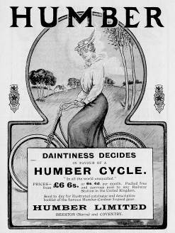
34 NORTH EAST CYCLING. The programme of the thirty-first annual North-Eastern cyclists’ meet, to be held at Barnard Castle on June 2, 3, 4 and 5. Newcastle: N. England Printing Co., Ltd., 1906.
18cm. 52pp, portrait plates, illustrations and cycling adverts throughout. Original pictorial card wraps, stapled. Minor rubbing to spine; staples rusted with minor associated staining. £35

35 PICKLES, William Norman. Epidemiology in country practice. With a preface by Major Greenwood ... Bristol: John Wright and Sons; London: Simpkin Marshall, 1939.
8vo. viii, 110pp, 2 plates (one double-sided), double-page colour chart, text plan and section, text charts and diagrams (some colour). Original blind-stamped brown cloth gilt, glassine-protected lightly chipped dust wrapper. £80
Now recognised as a significant contribution to epidemiology. William Pickles (1885-1969) recorded observations on infectious diseases throughout Wensleydale. Loosely inserted are 5 offprints from various journals, written or co-authored by Pickles, plus a typescript copy of Joan Pomfret’s panegyric ‘This way his path’.
The copy of the Yorkshire author Marie Hartley, with her initials to the front free endpaper - as an inhabitant of Askrigg Miss Hartley may well have been a patient of Pickles.
The book was reprinted in 1949 and 1972 and issued as a paperback in 1984.

36 CHEDDLETON FELONS. Rules of the Cheddleton Association for the prosecution of felons. Leek: printed by James Rider, 1859.
18cm. 8pp. Sewn. £55
COPAC BL only.
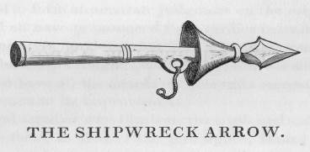
37 MURRAY, John. A description of improvements on the life boat, &. London: Effingham Wilson; printed by T.H. Skelton, Southampton. 1838.
8vo in fours. xvi, 16pp, 2 plates. Recent ‘old’ blue paper wraps. £220
Murray’s initial experiments with the shipwreck arrow were carried out on the Isle of Man in 1817. These experiments continued for the next fourteen years, and by the end of 1831 the apparatus was fitted to the lifeboat at Whitby. In the pamphlet Murray was at pains to point out that his invention was not a mere replica of George Manby’s; his list of 12 critical notices (naturally all positive!) came from such diverse publications as “The Spectator” and “The Nautical Magazine”. Several drew attention to the superiority of Murray’s work including “The Mechanics’ Magazine” of May 26th 1832 which stated “If Capt. Manby was thought well deserving of £3,250 for his imperfect apparatus, it cannot be that the inventor of one in every respect superior to it, should be suffered to go wholly unrewarded.” In spite of this, Murray’s system was not adopted, and Manby became the person associated with the history of lifeboat safety.
Not in the BL integrated catalogue, NSTC, COPAC or OCLC.

STRAW HATS FROM KENDAL

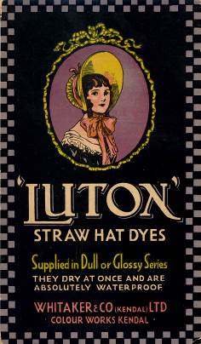
38 WHITAKER and CO (KENDAL) LTD, Colour Works, Kendal. ‘Luton’ straw hat dyes ... N.D.
Colour-printed pictorial three-panel (23 x 13cm. per panel) advertising brochure, 2 of the internal panels with 24 vari-coloured real straw samples laid down, integral grease-proof paper guard. Extremes lightly rubbed. £45

39 A summary view of the proposed canal, from Leeds to Liverpool; and of it’s (sic) importance to the public. Leeds: printed by Griffith Wright, 1770.
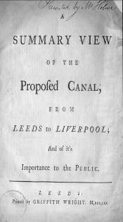
Small 4to. 15[1]pp, 7[1]pp postscript, head and tail-pieces, decorated capitals. Nineteenth century purple grained-cloth gilt. Re-backed in matching cloth with original spine laid down; spine and cloth partly browned; paper repair to upper corner of title page without loss of text; light soiling to fore-edge margins. Ex-Law Society with light oval ink-stamps to title and last page. £550
James Brindley published estimates of this proposed canal in 1766 and a plan, as part of The History of Navigation Part I, second edition, in 1769.; two plans by J. Longbottom were published in [1768?] and [1770] (see Skempton 853 and 854). This work was first published in 1768 without the postscript.
ESTC: L, LEp.

40 FOX, Lady Mary (Editor). The country house, (with designs). [At head of titlepage:] Friendly contributions for 1842. London : J. Murray, 1843.
4to. viii, 65[1]pp, 4 uncaptioned tinted lithographs by Day and Haghe from images on zinc by G. Moore, plus a lithograph plan, woodcut vignettes and elaborately designed initial letters to each chapter Original blind-stamped green cloth gilt. Neat repairs to rear joint. £300
A series of letters by A. de Chateauneuf, translated from the original German, on ‘the best style to be adopted for domestic architecture’. Charles L. Eastlake has added a letter on the principles of interior decoration. Any profits from the sale of the book were to help fund the Royal schools of industry at Kensington, The Potteries, and Shepherds’ Bush.
COPAC: BL, Oxford, V and A.
Not in Abbey Life.

PROOFED EDITION OF DAVISON’S ALNWICK BY THE AUTHOR.
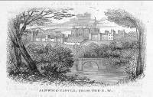
41 [DAVISON, W.] Description of Alnwick Castle. [Alnwick: printed by and for W. Davison,] N.D.[1846]
12mo in sixes. pp[5]-24, 29- 40 , text illustrations. Lacks title page and preface leaf, also B5 and 6. Later plain-paper wraps. Various marginal notes, ‘ticks’ and other proof reading marks throughout. £140
This work is attributed to William Davison of Alnwick by Anderton, who lists an edition of 1851. Comparison with the Anderton copy at Newcastle City Library indicates that our assorted alterations have been incorporated into the 1851 text. What is offered here, albeit incomplete, is Davison’s own marked copy for the later edition.
Isaac10. Hugo 4400 ‘With a vignette by Thomas Bewick at page 24, and the beautiful cut of the Percy Arms at page 40’ - both present in the copy offered here.

SPLENDID ASSOCIATION COPY WITH THREE WASH-COLOUR SKETCHES BY THE ILLUSTRATOR.
42 JENNINGS, Louis J. Rambles among the Hills in the Peak of Derbyshire and the South Downs. London: John Murray. 1880.
8vo, xviii, [ii], 391[1]pp. 6 plates and 17 text illustrations ‘from sketches made on the spot and drawn on wood by A. H. Hallam Murray. Engraved by J.W. Whymper.’ Full citron crushed morocco gilt, spine lettered direct, raised bands, elaborate inner dentelles, top edge gilt o/w uncut, marbled endpapers. Signed binding by Riviere. Large paper copy? £1,000
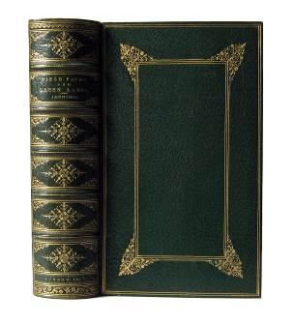
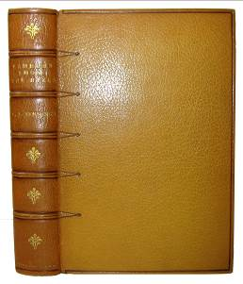
A special copy with the plates in three states, two before letters on ordinary and india paper. In addition there are three 12 x18cm original wash coloured sketches by Hallam Murray bound in; each verso is captioned and initialled by him in ink, and the actual artwork signed with his monogram. The three titles are: ‘In the woods, Chatsworth’, ‘View from Froggat Edge’, and ’ The village of Harting, Sussex’. Finally there is, loosely inserted, a four page ALS from the illustrator to the author dated January 30 1881 written from Rose Castle, Carlisle (official residence of the bishop); its general tone is ‘chatty’ but references to East Meon (‘vide p.155 “Rambles among the Hills”’ as Murray states) make it relevant. A. H. Hallam Murray (1854-1934) was a family member of the book publishers John Murray, joining the firm in 1876 and becoming a partner in 1884. A student of the Slade School of Art, he was a fine watercolour artist specialising in outdoor scenes and views; he also illustrated a number of topographical works and in 1904 held an exhibition of watercolours at The Fine Art Society. The sketches here are early examples of his work.
43 JENNINGS, Louis J. Field paths and green lanes being country walks, chiefly in Surrey and Essex.
London: John Murray, 1877.
8vo, xiv[ii], 293[1]pp. 8 full-page woodcut illustrations by J.W. Whymper. Extra illustrated with 95 steel copper and wood engraved topographical plates, all relating to adjoining text. Contemporary full dark green crushed morocco gilt extra, raised bands, double fillet to board margins and edges, enclosed double line fillet box bordered with pointille and foliate decoration to corners, finely decorated compartments and inner dentelles, top edge gilt o/w uncut, marbled endpapers. A binding of the highest quality, yet unsigned. Text lightly age-browned and foxed. £450
From the library of the author’s son, Richard Jennings, with a relevant letter to him loosely inserted. This was the first of two topographical works by Louis Jennings, a respected journalist with a passion for walking.

CUMBRIAN CIRCULATING LIBRARY CATALOGUE.
44 THURNAM, Charles. Catalogue of Thurnam’s Library, Carlisle; consisting of standard novels and romances, history, biography, adventures, voyages, travels, miscellanies, reviews, magazines, &. &. which are let out to read, at £1. 1s. the year, - half year, 12s, - quarter, 7s, - month, 4s, - or by the single volume at 1d. each evening. Carlisle: printed by and for Charles Thurnam, 1827-37.
12mo in sixes. 265[1]pp, consisting of 25 parts continuously paginated. Part 26, [ii]267-287[1] pp loosely inserted, unpaginated title pages to parts 22 and 26 included plus pp 221-[226] further ‘reduced prices’ section at end of part 22.
Bound with:
Thurnam’s Library, Carlisle. [Carlisle: Charles Thurnam,] 1833. 16cm. [4]pp.
Bound with:
CADELL, Robert. [Publisher’s Catalogue including] Sir Walter Scott’s Poetry. Edinburgh: Robert Cadell. 16cm. 16pp.
Bound with:
Catalogue of improved superfine colours, and drawing materials, of every description, ... Carlisle: Charles Thurnam, 1828. 15cm. 14pp.
Original dark green roan backed printed boards. Binding rubbed and browned; manuscript calculations and notes to endpapers; upper third of title page of part 26 torn away; lacks final leaf of 1828 Catalogue of ... superfine colours. Ballad...by Thomas Moore, printed on pink paper, laid down to front paste-down; ‘The Canadian Boat Song’ printed by the pupils of Croft House Academy laid down to rear paste-down. Further loosely inserted items include two of Thurnam’s engraved pictorial receipts with manuscript particulars dated 1833 and a fine trade-card for William Bewley’s Hesket-New-Market Academy, printed by P. Jollie in 1801. £500
The firm of Charles Thurnam was founded in 1816 and evolved into one of the major printing and publishing concerns in Cumbria during the nineteenth and twentieth centuries. It ceased trading, because of financial pressures, in 2008.
COPAC records 1856 and 1872 editions at BL. No other copies located.

45 CIRCULATING LIBRARY LABEL. Alexander Lawrie, bookseller, Edinburgh.
71 x 104mm engraved bookplate laid down to front paste-down endpaper of a single volume of The Scottish Register in original boards in exceptional condition. £75
Scottish Book Trade Index refers to Lawrie at 28 Parliament CLOSE in 1793/4.

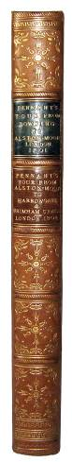
46 PENNANT, Thomas. A tour from Downing to Alston-Moor. London: printed by Wilson and Co. for Edward Harding; and sold by West and Hughes, 1801.
4to. viii, 195[1], 27 plates.
Bound with:
PENNANT, Thomas. A tour from Alson-Moor to Harrowgate, and Brimham Crags. London: printed by C. Mercier and Co. for John Scott, 1804. 4to. [x], 130pp, [2]pp publisher’s advertising leaf, 9 plates. Late nineteenth century tan half calf gilt, raised bands, decorated compartments, brown and green calf gilt spine labels, marbled sides and endpapers, top edge gilt. Light spotting and browning to front blank and half-title of the first work; light off-set from some plates. £380
Boyne 35 and 36 with the following note to the second work, ‘there are LARGE PAPER copies in Quarto of this and the preceding work; they are generally bound together.’
Fordham ‘The exploration of England’ 293 and 312.
Neither work in Upcott.

47 HOLDEN, John. Ancient lights: a paper read before the Sheffield Society of Architects and Surveyors, at a meeting held on February 12th, 1895. [Sheffield]: Printed for the Sheffield Society of Architects and Surveyors [by J. Robertshaw], [1895].
21cm. 32pp, text plan. Original limp maroon grained-cloth gilt. Spine and part of boards sun-faded; a few marginal pencil and crayon lines to fore-edge margins plus some underlining. £50
A brief, but interesting, look (citing cases) at the ‘right to light’ from 829AD to the time of writing. COPAC: BL, Sheffield. Nothing added in OCLC.

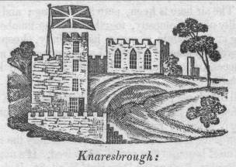
48 FORT MONTAGUE KNARESBOROUGH. An account of Fort Montague, at Knaresborough; in a letter, from a gentleman, at Harrogate, to his friend in London. Knaresborough: printed by W. Langdale N.D.
16cm. 8pp, engraved title page woodcut. Sewn. Small closed tear to upper margin of all pages where staple has been removed. £55
Certainly no earlier than 1821, the date of Hargrove’s 6th edition of the History of Knaresborough; this is advertised for sale on the final page.
COPAC. Oxford (c1811), BL (c1815?). Not in Boyne.

YORK MINSTER RESTORED
49 [HAREWOOD, Henry Lascelles, Earl of.] An account of the proceedings and resolutions of a meeting of the nobility and gentry of the county of York, held at the Festival Concert-Room, in York, on Thursday, the 5th day of March, 1829, to consider of the best means of restoring York Minster to its former state; with a list of subscriptions entered into, and reported to the Central Committee, to the 7th of March inclusive. York : [printed by H. Bellerby for] the Minster-Restoration Central Committee, 1829.
21cm. 16pp, [1]pp supplement.
Bound with;
[WELLBELOVED, Charles.] A letter addressed to the subscribers to the restoration of the choir of York Minster, on the subject of the proposed removal of the organ screen. By a subscriber. York: printed by Thomas Wilson and Sons; and sold by J. and G. Todd, 1830. 8vo. 36[2]pp, engraved plan.
Bound with:
VERNON, W[illiam] V[ernon]. A letter to Viscount Milton, on the restoration of York Minster, and the proposed removal of the choir screen. York: John and George Todd, 1830. 8vo in fours. 29[1]pp
Bound with:
[WELLBELOVED, Charles.] A letter addressed to the Rev. W. V. Vernon, F.R.S. Can. Res. of York Cathedral, containing remarks on the postscript of his letter to Lord Viscount Milton. By a subscriber. York: printed by Thomas Wilson and Sons; and sold by J. and G. Todd, 1830. 8vo. 19[1]pp.
Bound with:
[ROBINSON, P. F.] Observations relating to the proposal for removing the choir screen in York Minster. By an Architect. York: [printed by Thomas Wilson and Sons for] John and George Todd, 1830. 21cm. 13[1]pp.
Bound with:
VERNON, W[illiam] V[ernon]. A second letter to Viscount Milton, on the restoration of York Minster, and the proposed removal of the choir screen. York: [printed by W hargrove and Co for] John and George Todd, 1830. 8vo. 62pp, engraved plan.
Bound with:
[WELLBELOVED, Charles.] A second letter addressed to the subscribers to the restoration of the choir of York Minster, on the subject of the proposed removal of the organ screen. By a subscriber. York: [printed by Thomas Wilson and Sons for] John and George Todd, 1830. 8vo. 55[1]pp.
Bound with:
BROWNE, J[ohn]. A letter addressed to the Ven. and Rev. Archdeacon Markham, on the construction and date of the porch of the organ-screen in York Minster: containing remarks on the statements of the Rev. W.V. Vernon and J. Savage. York: printed by Thomas Wilson and Sons; and sold by J. and G. Todd, 1831. 21cm. 15[1]pp, multi-folding etched frontis, folding etched plan.
Bound with:
A letter addressed to Lord Viscount Morpeth, on the removal of York Minster screen. By Clericus. And a prospectus of a mock heroic, entitled York Minster screen; or, The Trojan war renewed: by Philo-homerus. York: published and sold by H. Bellerby, 1831. 8vo. Pp [i]-iv, [5]-30, [2]pp key.
Bound with:
[SMIRKE, Robert.] A report addressed to the subscribers for the restoration of York Minster, on the proposed removal of the choir screen. London: printed by C. Whittingham, 1830. 8vo. 31[1]pp.
Bound with:
GAGE, John. Remarks on the alterations proposed in York Minster, in a letter from John Gage, Esq. F.R.S. Director of the Society of Antiquaries, to Francis Cholmeley, Esq. of Brandsby, in the County of York. Read at a meeting of the Society, on Thursday, February 18, 1831. London: printed for J. F. Dove; and Messrs. Todd, York, 1831. 21cm. 15[1]pp.
Bound with:
SMIRKE, Robert. A letter to Henry Ellis, Esq. F.R.S. Secretary of the Society of Antiquaries, from Robert Smirke, Esq. R.A., F.S.A. on the late proposal to remove the choir screen in York Minster. Read at a meeting of the Society, on Thursday, February 24, 1831. London: Priestley and Weale, 1831. 21cm. [ii], 16pp.
Bound with:
On the proposed removal of the choir screen, in York Minster. (Extracted from the York Courant, of February 1, 1831.) York: printed by T. Stones. Broadside 32 x 20cm. printed in double-columns.
Contemporary half maroon calf gilt, raised bands, decorated compartments, red calf gilt spine label, marbled sides, endpapers and leaf-edges. Board edges lightly rubbed; occasional light spotting; piece torn away from lower fore-edge corner of first work title page not affecting text; lower part of a John Mitchell’s book-plate to front free endpaper - upper part torn away. £1,300
Collection of 13 items printed 1829-1831 concerning the removal of the choir screen as part of the general restoration of the Minster.

RESPECTABLE PHRENOLOGIST IN SCARBOROUGH

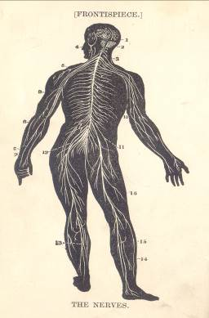
50 WELLS, R[obert] B[lockley] D[odds], phrenologist, Scarborough. Complete works on health; embracing 1. Good health, and how to secure it; 2. Health and economy in the selection of food; 3. Water, and how to apply it in health and disease; woman: her diseases, and how to cure them; 5. Best food, and how to cook it. Leeds: printed by Fred. R. Spark, “Leeds Express” Printing Works for: H. Vickers, London; James Coates, Glasgow; W. H. Robinson, Newcastle-on-Tyne; J. B. Keswick and the Author, Scarborough, N.D. £160
8vo. [ii], 208pp, [8]pp adverts, frontis, text illustrations; 36pp; 72pp, [8]pp adverts, text illustrations; 98pp, [6]pp adverts; 144pp. Contemporary black half calf gilt, raised bands, mauve grained-cloth sides, marbled leaf-edges.
A collection of five of Wells’ works brought together in one volume and published with a general title page.
We have been unable to locate any copy of the ‘Complete Works.’ Four of the individual titles are held at BL with dates assigned from 1878 to 1893; the unrecorded title is ‘Water and how to apply it ...’; ‘Woman: her diseases ... ‘ is a different issue with the imprint J. Burns. Collections of testimonials and ‘opinions of the press’ are scattered throughout the volume.
It would be an understatement to say that by today’s standards ‘Professor’ Wells was odd, however for the late Victorian period he earned the mantle of respectability. His practice as a phrenologist was situated initially at Pavilion Place, Scarborough; but by the time the ‘Complete Works’ was published he was established at Observatory Villa, West Bank - after building extensions were carried out it became the Scarborough Hydropathic Establishment which continued in operation until Wells’ departure in 1900.

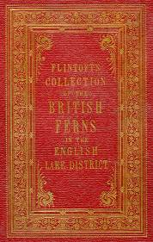
51 [FLINTOFT, James.] Flintoft’s collection of the British ferns in the English Lake District. [Keswick] c.1845.
29cm. 37 specimens, each named and located in manuscript. Original red cloth gilt, decorative blind-tooling to boards, decorative gilt section with lettering to front board, sprinkled leaf-edges. Spine faded with wear and minor loss to extremes; cloth lightly spotted and soiled; staining to corner of front board. £260
These “collections” were probably produced to order for individual customers and, as such, are undated; the binding is distinctively mid-nineteenth century.
Not in Freeman, who records Flintoft’s volume of mosses (no.1205) and ascribes a date of [c.1830].
Three copies of ferns are recorded in COPAC: 1) NLS. [39] leaves [s.n. ca, 1860]. 2) Leeds [37] leaves [ca, 1840]. 3) Manchester [37] leaves [ca. 1840].

PROSPECTUS FOR MAJOR LINCOLNSHIRE TOPOGRAPHICAL WORK.
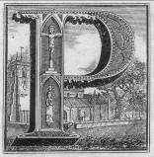
52 NOBLE, John Lincolnshire topography. Preparing for publication; collections for a topographical and historical account of the Wapentake of Candleshoe, and of Spilsby and Eresby, in the county of Lincoln. With engravings on copper and wood, by eminent artists, by Joshua Cheffins. N.P. c.1828.
Broadside. 562 x 424mm. Printed in 3 columns which list subscribers and provide a contents resumé. Horizontal and vertical creases; lightly soiled. £280
Although the book was published in 1829 this broadside was printed no later than 1828, the year the Rev. Edward Booth, vicar of Friskney and subscriber 23 to a large paper copy, died. Scrutiny of the subscribers list would probably give a more precise date of publication.

A QUAKER IN SYRIA

53 FOX, M.J. (Editor and Compiler). Journals and letters of Alfred Lloyd Fox. N.P. c.1885.
27cm. iii, 220 leaves, typescript on versos only. Contemporary black crushed morocco, gilt lettering to front board; coloured leaf-edges, later matching re-spine; minor wear to board corners; hinges repaired; few ink splashes to front free endpaper, occasional ink or pencil alterations to text. £260
Alfred Lloyd Fox was the eldest of the 12 children of Alfred Fox and Sarah Lloyd, who had married in 1828. The family had strong connections with Cornwall, especially Falmouth, where Fox was brought up at Wodehouse Place. This family copy is taken from original manuscripts and was compiled and edited by M[ary] J[ane] F[ox], Alfred’s wife, who died in 1919; what is in effect, the preface indicates that the contents were for family consumption only.
Fox was well-travelled and this is reflected in the Journal: two chapters are about visits to Syria in 1867 and 1878 and another three give details of journeys within Great Britain; one specifically to Shetland.

54 DODD, R. A short historical account of the greater part of the principal canals in the known world. With some reflections upon the general utility of canals in a letter addressed to the subscribers for the survey of the intended navigation from the East-West sea, by way of Newcastle and Carlisle Newcastle Upon Tyne: printed for and sold by W. Charnley and J. Bell; Newcastle: F. Jollie, 1795.
4to. iv, 27[1]pp. Recent blue-paper boards, paper label to front board. Text lightly age-browned. £200
In 1794 Dodd undertook the preliminary survey for a proposed Newcastle to Carlisle canal. The following year he carried out a detailed survey from Stella to Hexham following a route south of the Tyne. It was the intention to publish as early as possible but “the long continuance of the late inclement weather” (advertisement leaf of the item offered here) prevented this, and it was June before it came off the press. As an interim measure, and to keep potential investors and subscribers happy, the present pamphlet was published in March. It was a hurried affair and of little value to those interested specifically in the East - West crossing. Indeed Skempton notes that it was “plagiarised from Phillips’s General History of Inland Navigation.” In any event neither work received universal approval and a further report was written by John Sutcliffe in 1796.
ESTC L, Lse, Lrag, MRu, NCl, NCp, O; C-S, NIC, MH-BA, NN, IU; Au NSL-RB.
COPAC adds Newcastle University Library.
Skempton 372: BM, BDL, Elton. Anderton page 92. Not in Goldsmiths.

55 [HUTTON, John.] A tour to the caves, in the environs of Ingleborough and Settle, in the West-Riding of Yorkshire. With some philosophical conjectures on the deluge, remarks on the origin of fountains, and observations on the ascent and descent of vapours, occasioned by facts peculiar to the places visited. Also a large glossary of old and original words made use of in common conversation in the North of England. In a letter to a friend. London: printed for Richardson and Urquhart; J. Robson; W. Pennington, Kendal, 1781 2nd edition, with large additions.
8vo in fours. [ii], iv, 100pp, head and tail-piece. Later quarter vellum with inlaid black calf gilt spine label, marbled sides, later endpapers. Extremes very lightly rubbed; vellum spotted; occasional light spotting - heavier to second gathering; last page lightly soiled. £450
Alston ix, 45; Cox pp 28-29; Boyne 178.
ESTC t072524.

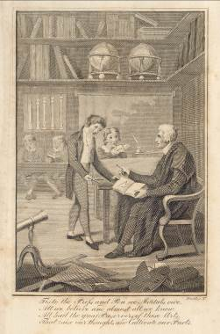
56 FISHER, George. The instructor, or, Young man's best companion: containing spelling, reading, writing, and arithmetic ... In this work is also given a compendium of the sciences of geography and astronomy ... ; and some useful interest tables A new edition, corrected and improved throughout, by N. Downes. London: printed for Dean and Munday ... ; and T. Top edge gilt ..., [1822].
12mo. 288pp, engraved frontis, 2 folding plates, text figures and tables. Contemporary full tree-calf gilt, small printed paper spine label, blue endpapers. Extremes lightly rubbed; plates spotted; light off-set from frontis to title page. With the label of S. Jefferson, bookseller, of Cockermouth to front paste down endpaper. £55
Possibly a provincial (Cockermouth) binding with a small lozenge-shaped paper label to the spine indicating shelf or book number.
COPAC: this edition with precise collation as here at Nottingham only. Another 1822 edition with different imprint is held at Liverpool.

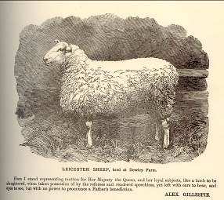
57 GILLESPIE, Alexander. The new testament of agriculture. Newcastle upon Tyne: printed by J.M. Carr, at the City Steam Printing Works, 1895.
4to. Various pagings, plates with guards, folding tables and forms. Original decorated red grained-cloth gilt, bevelled edges, patterned endpapers. Cloth rubbed with very slight wear; cloth lightly soiled; frontis recto spotted and browned. £225
Unusual Northumberland item - principally comprises an account of the author's claim against the Duke of Northumberland for agricultural improvements on Dewley and Crescent farms under the Agricultural Holdings Act, 1883.
Internal evidence provides a latest date of 1902 for material included in the volume; elsewhere dates of 1897 and 1899 are common. The final two leaves, comprising advertising and order form, state that a 3rd edition contains extra material and runs to 382pp; on a rough count our copy is 500pp + - possibly a 4th edition?
COPAC lists a copy at Newcastle with 272pp, that at BL is given as 241pp (initial index indicates this copy incomplete). No copy appears to contain the additional material found here.
Both COPAC and OCLC have no records for either Hold House Farm or Stephen Fairbairn/ J. F. Laycock.
Not in Sweet and Maxwell.
EDWIN CHADWICK CONTRIBUTES

58 CARLISLE, Earl of. Report on a general scheme for extramural sepulture. Presented to both houses of parliament by command of Her Majesty. London: printed by W Clowes for HMSO, 1850.
8vo. 172pp, multi-folding plan, printed in red and black, at rear. Original blue card wraps. Light soiling to first few leaves. £260
Although this report was issued under the chairmanship of the Earl of Carlisle, his three co-members were exceptional nineteenth century social reformers, viz. [Anthony] Ashley[-Cooper], Edwin Chadwick, and T.Southwood-Smith. Additionally two general reports ‘on the Practice of Intramural Internment in the Metropolis’ and ‘on the Practice of Internments in Germany and France’ were submitted by John Sutherland, a significant provider of evidence to the main report.
The thrust of the enquiry was to examine the health risks of overcrowded burial sites situated in densely populated urban areas, expecially in the light of the recent cholera oubreaks. Assessment was centred primarily in London, Liverpool and Manchester, and secondarily in Taunton, Sheffield, Neath and Merthyr. One of its most important considerations was that of discontinuing burials within the Metropolis.
Recommendations in the report were heeded and a series of Burial Acts were passed between 1852 and 1859 which took major strides to ameliorate conditions.

59 BRADLEY, Frederick. Thistle-down. Verses ... Sheffield: printed by the Author’s own hand, at his private press, 1882.
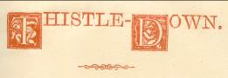
26cm. [72]pp, head and tail-pieces, decorated capitals, printed in red and black on laid paper watermarked ‘Antique Vellum Wove’. Original decorated maroon cloth gilt, bevelled edges. Ticket of Loxley Brothers to front paste-down. Spine faded; light wear to extremes; cloth lightly rubbed and soiled. £180
Although the index gives page numbers these are not present on the leaves; instead there are a series of pencil numbers to lower right margin of each leaf. Perhaps a special (large-paper?) copy.
This seems to be the sole recorded work by the author. He is listed in neither North Country Poets nor Modern Yorkshire Poets, both by William Andrews. COPAC: BL. Nothing added in OCLC.

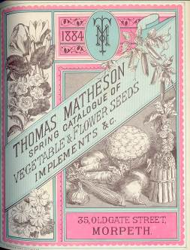
60 MATHESON, Robert, Nursery and Seedsman, Morpeth. Descriptive catalogue of florist flowers and bedding plants ... [Comprising: bound copies 1871-1899, with the Spring 1870 catalogue loosely inserted. Six other ephemeral items bound in.]
Various pagings. Later green half-style grained cloth, original wraps bound in. Although there is no evidence, internal or external, we feel this may be a ‘file copy’ put together by the firm.
Catalogues to 1878 were printed in Newcastle and unillustrated. From 1879, when Thomas (son of Robert) took over the running of the business, illustrations were used and printed covers, lithographed by John Baxter of Edinburgh, featured; in 1884 these were replaced by the striking chromolitho designs of Thomas Forman of Nottingham. £1,500
From a note at the rear of the 1896 catalogue relating to ‘Whinham’s Industry Gooseberry’ we learn that Robert Matheson took over Robert Winham’s business in 1858 when the latter was 82 years old. Whinham a native Morpethian, specialised in gooseberry cultivation and, in general, Morpeth hosted many local gardening firms: Watson, Temple, Sanderson and Oram, to mention a few.
Initially Matheson’s specialised as a tree nursery, developing into a general nurserymen as time passed.
NRO hold 1883-84 Catalogue of Forest Trees and Shrubs ... , with the 1884 Spring Catalogue of vegetable and flower seeds ... (as present here). These are part of the Swinburne (Capheaton) Estate Records.
The complete archive of Thomas Matheson and Son is held at Northumberland Record Office; it was deposited in February 1976 and contains none of these early catalogues.

61 Historical pastime: a new game of the history of England, from William 1st to William 4th. London: published by Edward Wallis, N.D.
49cm x 49cm approx., 12 panels hand-coloured and laid down on linen.
With: Rules and directions for playing the historical pastime, or, New game, of the history of England. London: printed [by T. Davis] for E. Wallis and J. Harris, 1828. 17cm. 24pp. Original plain card wraps, sewn. Original card slip case with [undated] hand-coloured printed label. Case rubbed and worn. £495
COPAC: J. Harris edition of 1806 plus E. Wallis editions of 1838? and 1840? OCLC adds 1808, 1810 and 1824 Harris/Wallis editions, together with this edition, with a central portrait of George 4th, at Huntington.
Whitehouse ‘Table games of Georgian and Victorian Days’ pp 27-29 noting that the board here with a central portrait of William IV was produced c.1832. See also Gumuchian 3276.
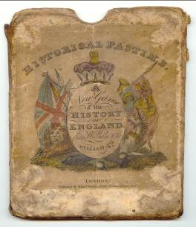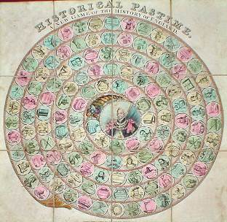

THE WORKS OF GEORGE ELIOT.
62 ELIOT, George, pseud Mary Ann Evans.Works. Comprising: Adam Bede; The Mill on the Floss; Silas Marner; Romola; Felix Holt, the Radical; Middlemarch; Daniel Deronda; Impressions of Theophrastus Such; Scenes of Clerical Life; The Lifted Veil; The Spanish gypsy; The legend of Jubal and other poems, old and new; Essays and leaves from a note-book (10 works in 8 volumes). New York: William L. Allison, [1888-89].
8vo. Extremes lightly rubbed; small leather flaw to third compartment of Silas Marner; small chip to title label of Romola. £420
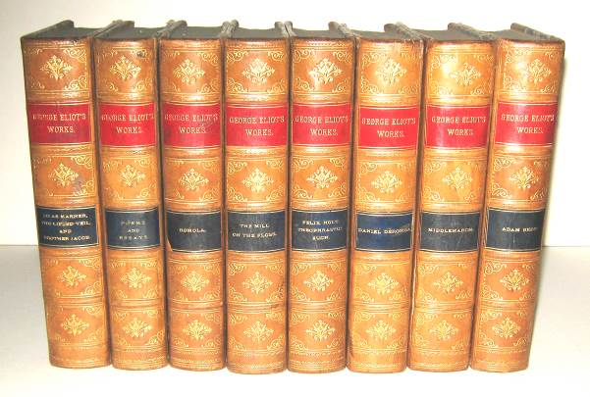

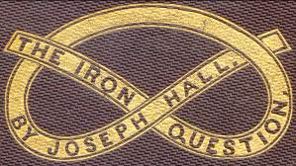
63 HALL, Joseph. The iron question: considered in connection with theory, practice and experience, with especial reference to "The Bessemer process.". London: Hamilton, Adams, and Co., 1857.
8vo. 73[1]pp, 2 folding plates. Original decorated blind-stamped maroon cloth gilt. Fore-edge margin of one plate chipped without affecting image. £145

YORKSHIRE VIES WITH LONDON
64 [SHAW, George.] Guide to Filey and the neighbourhood: historical and descriptive. Filey: printed and published. for S. Towse, by Chas. H. Dawson, Grimsby, 1878.
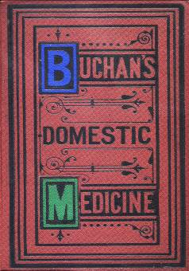
8vo. 95[1]pp, [12]pp adverts, text tables, tail-pieces.
COPAC: York Minster.
Bound with:
[HOFMANN, August Wilhelm von.] The visitors' guide, to Harrogate, Ripon, and adjoining country, including Fountains Abbey, Brimham, Bolton, Hackfall, Knaresborough, and other places of interest. Ripon: James Fairburn, N.D. 18cm. 120pp, folding map frontis, title page vignette.
Two editions in COPAC dated 1854 and 1858; this does not conform to either and ‘feels’ like a later reprint c.1875?
Bound with:
CORTIS, William S[mithson]. An historical and descriptive guide to Filey. Filey: M. T. Kendall, 1861. 12mo. 83[1]pp, [8]pp adverts (including a fine trade card), multi-folding plan frontis, 3 Rock and Co vignettes.
Not in COPAC or Boyne.
Bound with:
GRUNDY, John. The stranger's guide to Hampton Court palace and gardens. London: Bell and Baldy, 1864. 18cm. 96pp, 2 plates, text tables, plan of the maze printed on pink paper.
Numerous editions between 1843 and 1864; however this 1864 dated edition not in COPAC.
Bound with:
Westminster Abbey; its history, antiquities, and tombs, a hand-book guide for visitors. London: H.G. Clarke and Co., 252, Strand, [1863]. 18cm. 16, [64]pp, multi-folding circular map of London c.1863 in the form of an advertising leaflet, title page vignette, text illustrations and plan.
COPAC: V & A.
Later half black calf gilt, raised bands, decorated compartments, matching grained-cloth sides, marbled endpapers, top edge gilt. £295
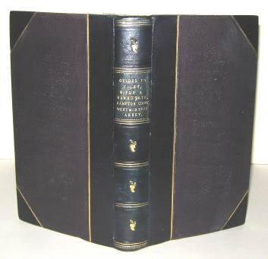

65 BUCHAN, William. Domestic medicine; or, a treatise on the prevention and cure of diseases by regimen and simple medicines; with an appendix containing a dispensatory for the use of private practitioners. London: Milner and Co., N.D. new and enlarged edition containing new treatises on sea-bathing, mineral waters, vaccine inoculation, diet, &. &.
17cm. xxiv, 534pp, [2]pp publisher’s catalogue, folding colour frontis, 6 double-sided plates. Original decorated brown cloth gilt. Cloth very lightly rubbed; small isolated light stain to spine. £70
From the single leaf catalogue at the rear of the volume a date of [1870] would seem appropriate.
William Buchan (1729-1805), Scottish Physician and author of the eighteenth century best-seller ‘Domestic medicine’. By 1800 it had reached its 17th edition and continued to a 21st edition in 1813, after which, copies were designated ‘new edition’. Christopher Lawrence, in Buchan’s entry in ODNB, notes that there were at least 142 separate English language editions; additional translations were made into Spanish, French, Welsh, Italian, German, Russian, Swedish and Portuguese. The book was so successful it was still in use in the 1920’s.
This edition not found in COPAC - details below of similar holdings:
Wellcome Library: an [187-?] edition with same pagination and [10]pp of plates. Imprint is Milner and Sowerby.
Edinburgh UL: same imprint with identical pagination, no plate count, and a date of [1850?].
Bradford (REES Special Collections) : the same pagination and details of the frontis - anatomical images, tapeworm, colour plate of child with "measels" but with a date, from the dedication of [1782] - presumably [1872].
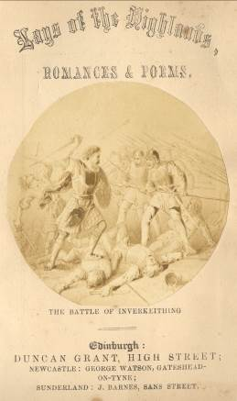
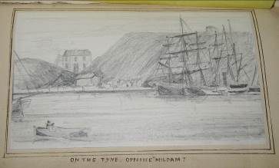
EXTRA ILLUSTRATED WITH THE AUTHOR’S DRAWINGS AND WATERCOLOURS.
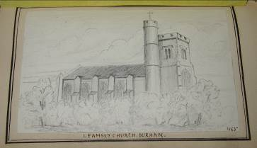
66 SOMERVILLE, George W. Lays of the Highlands, romances and poems. Edinburgh: Duncan Grant; Newcastle: George Watson; Sunderland: [printed by] J. Barnes, 1866.
18mo. 14cm in gatherings of 9 leaves. x, 230pp, additional engraved title page with circular plate laid down.
COPAC: BL, NLS
Bound with:
[SOMERVILLE, George W.] The Hermit of Inchcolm: a romance of the 17th century. Also, a tour to Inchcolm: being an historical and descriptive account of the island By "Prince Charles Edward". Illustrated with photographs from original sketches by the author. Edinburgh: Duncan Grant; Gateshead: George Watson; Carlisle: Hudson, Scott and Sons, 1866.
14cm. 38pp. Lacks the view of the Island of Inchcolm called for at page [4]. Contemporary half black calf gilt, marbled sides and endpapers, coloured leaf-edges. £825
COPAC: NLS. Not in Mitchell’s Tours.
Extra illustrated with c70 original pencil sketches, watercolours, and drawings by Somerville, principally of Northern topographical interest. Carlisle, Newcastle and Scottish scenes figure prominently; of those dated most are 1865/1866.

67 CHICKEN, Edward. The collier's wedding. A poem. Newcastle: printed by T. Saint, and sold by the booksellers in town and country, 1773 4th edition.
8vo in fours, 32pp, head-piece. Later red half-calf gilt, matching cloth sides, marbled endpapers. Binding lightly rubbed; text lightly browned and spotted. £750
A famous Newcastle poem written, according to Foxon’s researches, in 1729, and first published by John White in the 1730’s. A single copy is recorded (Foxon c147) at Newcatle University Library - mutilated and lacking A1 and I2. The poem was popular and reached a 10th edition by 1800; most of these are represented by a single copy in ESTC. Although Chicken’s output was limited - Foxon and ESTC find only one other piece by him - Richard Welford, the Newcastle author and local historian, considered him worthy of inclusion in his ‘Men of Mark twixt Tyne and Tweed’ (Vol. 1. pp 546-549).
Chicken’s early life was difficult and his father, a weaver, died young. Eventually he opened a school at the corner of Newgate and Low Friar Streets. Little else is known of him apart from his marriage to Ann Jordan of Newcastle, plus his death in January 1746/7. As for the poem, Welford considered it ‘not very pleasant reading. It [bore] strong traces of the impurities that characterised a preceding age’; however its coarseness and vulgarity were enjoyed by contemporary readers. By the time an 1827 edition was published by T and J Hodgson the language had been toned down.
ESTC: MH.

EDINBURGH BOOKSELLERS AT ‘WAR’.
68 [WILLIAMSON, Peter.] The trial of divorce, at the instance of Peter Williamson printer in Edinburgh, against Jean Wilson, daughter of John Wilson, bookseller in Edinburgh, his spouse. Containing the whole proceedings at large. With a prefatory introduction, Giving some account of the adulterous gallants and reasons for suing the divorce, and for publishing the proceedings in it. Edinburgh: printed for and sold by the booksellers in Edinburgh, Leith, &c, 1789.
8vo in fours. 62pp. Modern quarter-style paper boards. Small neat repair to title-page - not affecting text; light spotting and browning to preliminary leaves. £795
This work is an account of the acrimonious divorce of Peter Williamson and Jean Wilson. Williamson was a colourful character who became a notable Edinburgh printer and publisher; however, it was his earlier life amongst the native American Indians which captured the public imagination; indeed the portrait included in his ODNB entry shows him in the dress of a native American of Delaware.
The introduction (xxiv pp) is certainly written by Williamson; indeed, the Scottish Book Trade Index entry for him notes that this was one of his publications, even though the imprint states ‘Printed for and sold by the Booksellers of Edinburgh, Leith ...’ - perhaps an attempt to imply impartiality in a sensitive case. Nonetheless, there is ‘point scoring’ throughout, and this against another Edinburgh notable - John Wilson.
ESTC: L, E. O; MH-L.
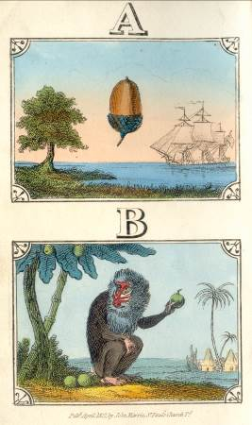
69 The royal primer; or, High road to learning; with The rational alphabet, or. Rudiments of reading. London: John Harris, N.D. [1843].
18cm. 34pp, 12 hand-coloured plates. Original printed stiff-card wraps, stab-sewn. Professionally re-spined with matching plain card. £575
The publishing details given on the front wrap are: ‘London: published by Grant and Griffith, successors to John Harris, ...’.
Closest item found in COPAC is a Harris imprint of the first part of the title dated 1835; this recorded with 10 coloured plates rather than the 12 here. Moon 734 is more informative: pagination plus number and date of plates correspond exactly; however, the limp green cloth cited does not afford the publishing details and advertising material found on the original wraps present here.
Philip Brown’s London publishers and printers c.1800-1870 gives the terminal date of John Harris’s publications as 1843; this concurs with Moon. His dates for Grant and Griffith are 1843-1856, and checks, where possible, of titles on the rear wrap indicate the sale of Harris publications dated 1841 and 1842. [Infamous Knowledge, 1842 for a 6th edition; similarly The ladder for learning, 16th, is dated 1841.] ‘Be Merry and Wise’ acknowledges the transfer of the business in 1843, doubtless the year this was published, and seven years beyond that given by Moon.

70 [PAYNE, William] Maxims for playing the game of whist; With all neccessary calculations, and the laws of the game. London: Sold by T. Payne. 1773.
Small 8vo. [ii], 67[1]pp. Recent blue-paper boards, spine paper label printed using contemporary materials. Text lightly age-browned, heavier to title page and final page; small closed tear to fore-edge of title page; lacks rear free endpaper. £240
Jessel 1303, Horr 1004 (an edition of 1770, which is in neither ESTC nor Jessel).

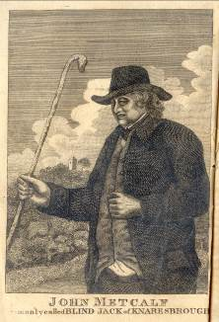
71 METCALF, John. The life of John Metcalf, commonly called Blind Jack of Knaresborough; With many entertaining anecdotes of his exploits in hunting, card playing, &c. Some particulars relating to the expedition against the rebels, in 1715.... Leeds: printed by G. Wilson. 1812.
12mo. in sixes. 72pp, ‘embellished with a striking half-length portrait’ frontis. Contemporary paper wraps, uncut. Wraps water stained; text lightly age-browned. £85
One of four editions published in 1812, and one of many up to 1881.
COPAC records Chethams Hospital for the Leeds imprint.

72 RIVER WEAR COMMISSION. First report of the committee of finance, appointed 7th July, 1841. Sunderland: printed by Thomas Reed and Co. 1841.
21cm. 10[2]pp. Original printed blue paper wraps, sewn, uncut/unopened. An exceptional copy. £50
Sunderland imprint.
Issued as a result of the Commission’s financial situation at the time. Useful for its breakdown of salaries and wages, many of the employees (e.g. Inspector of Nuisances, Inspector of Dredging, Boatman) were paid on a daily basis.

ORIGINAL MANUSCRIPT POEM BY THE AUTHOR
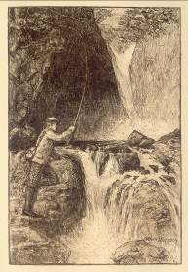
73 LANG, Andrew. Angling sketches. London: Longmans, Green, and Co. 1891.
8vo. xii, 176pp, 3 etchings and numerous illustrations by W.G. Burn-Murdoch, [4]pp publisher’s adverts to rear. With a signed manuscript four line verse, by the author, loosely inserted. Original bevelled-edged green cloth gilt, coloured endpapers, top-edge gilt otherwise uncut. Minor rubbing to spine tips; ink signature to front free endpaper verso; text lightly age-browned with some foxing to prelims and final pages. £150
Excellent copy of the ordinary edition (a large-paper limited was also issued), together with an original contribution by the author.
Heckscher 1186.

74 AVERY Thomas. The corporation of Birmingham and the water supply of the town. A statement addressed to the members of the town council. Birmingham: “Journal” Printing Offices, December, 1869.
8vo. 30pp. Vertical crease; ‘Birmingham Medical Institute’ ink-stamp to title-page. £50
Contains useful comparative text tables.
The author was a member of the noted weighing-machine manufacturing family. He left the firm in 1864 to take up an active role in local politics: Mayor twice.
COPAC: BL.
NIGHTINGALE IN ORIGINAL CLOTH.
75 NIGHTINGALE, Florence. Notes on nursing: What it is, and what it is not. London: Harrison. [1864].
8vo. 79[1]pp. Original bead-cloth with blind-stamped rule bordering and grape vine and leaf design to corners, printed coloured endpapers with publisher’s advertisements. Cloth lightly rubbed to extremes; spine faded with sections of fading to front/rear boards and spine-edges; ink signature to top-edge of title page; small fractures to front paper hinge. £260
The front paste-down endpaper is dated 1864, this date is re-inforced by a further advert on the rear paste-down endpaper stating that William Banting’s ‘Letter on Corpulence’ is ‘just published’. COPAC confirms this publication date.
Details from Victor Skretkowicz’ ‘Florence Nightingale’s Notes on Nursing: The First Version and Edition’, are as follows: ‘The latest found in the third setting (Group 26) is January 1864 (page 28). ‘The charcoal bead-cloth bindings of Groups 1-29 are impressed with a rectangular border of blind rules that varies in number... Some copies with advertisements dated 1864 (Group 26a, Binding II) have grapes and vine-leaves at the corners as additional decoration within the frame’.
These later editions appear much scarcer in commerce than the 1859 and 1860 issues; indeed COPAC lists no copies after 1860 or before 1876.
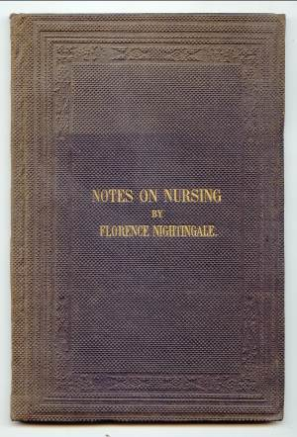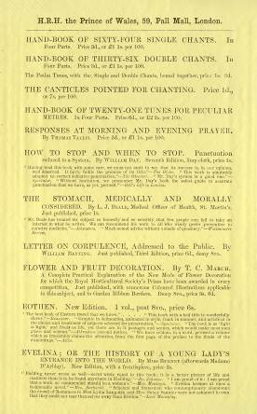

76 HOPE, John. The British League Evening Classes, or, Water versus whisky and tobacco: an answer to the Right Honourable Fox Maule, His Grace the Duke of Argyll, and the Rev. Thomas Guthrie, D.D. in regard to certain sentiments made by them at meeting in the Music Hall, 31st December 1850. Edinburgh: published for the author, by William Blackwood and Sons, 1851.
22cm. 31pp, text tables. Sewn. Title-page lightly browned and soiled. £80
John Hope’s life and career is well-chronicled in David Jamie’s ‘John Hope, Philanthropist and Reformer’. He was a prominent Edinburgh ‘Writer’ with a strong association to the George Heriot School and Hospital.

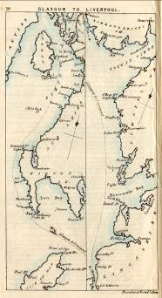
77 The steam and inland navigation of Scotland. In twelve maps with letter-press descriptions. Edinburgh: John Thomson and Co.; London: Baldwin and Cradock; Aberdeen: George Clark and Son. N.D. (c1838)
17cm. 24pp, in effect 12 tinted litho maps with accompanying letterpress descriptions. Original pink card wraps, paper label to front wrap. Wraps lightly soiled and spotted; text lightly age-browned with some minor foxing to prelims £95
Maps lithographed by Forrester and Nichol - in business in Edinburgh from 1831 to 1838, they commenced at No. 10 George St., moved to No. 3 in 1834 and No. 14 in 1838.

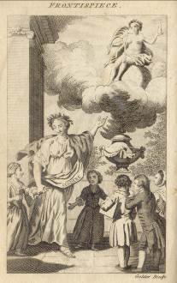
78 The young lady’s parental monitor: Containing I. Dr. Gregory’s “Father’s legacy to his daughters”; II. Lady Pennington’s “Unfortunate mother’s advice to her absent daughters”; III. Marchiones De Lambert’s “Advice of a mother to her daughter”. London: printed for Joseph Wenman. 1790.
12mo. in sixes. vii[i], 163[1]pp, frontis. Contemporary full calf, later re-back, original red calf gilt spine label laid down, sprinkled leaf-edges. Minor wear/rubbing to board extremes; ink lettering to corner of front free endpaper; ‘biro’ date added to title page lower margin; text lightly age-browned with some occasional minor spots of ink to prelims. £225
Published by Wenman in 1790 with a corresponding volume for young gentlemen. The work itself was not revolutionary - Dr. Gregory’s work was popular during the 1770’s and Lady Pennington’s the previous decade. The first English edition of Anne Lambert’s ‘Advice’ was published in 1729. By the time of this publication the Georgian young lady had every opportunity to be well-versed in all branches of conduct, behaviour and the other niceties of polite society.
ESTC. L, E; InU-Li, MSnE, OCIW.
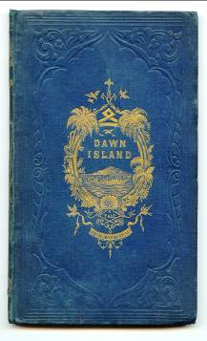
79 MARTINEAU, Harriet.Dawn Island. A tale. Manchester: J. Gadsby. 1845.
Minor rubbing to cloth extremes; minor wear to spine tips with some loss of cloth; spine and spine-edges lightly faded/spotted with some minor wear to the gilt decoration and lettering; text lightly age-browned with some minor foxing to prelims. £90

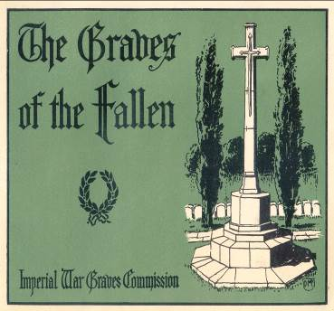
80 KIPLING, Rudyard. The graves of the fallen. The descriptive account of the work of the Imperial War Graves Commission. The illustrations showing the cemeteries and memorials as they will appear when completed are by Mr. Douglas Macpherson. London: H.M.S.O. [1919]
Landscape binding. (28 x 21cm) 16pp, 7 plates. Original pictorial card wraps, stapled. Wraps lightly soiled; staples rusted with some associated staining; contents loose from wraps. £140
An uncommon piece of Kiplingiana.
Martindell 165 ‘This pamphlet... is only to be found in this edition’.
Stewart 433 ‘From its inception, Kipling was a member of the Imperial War Graves Commission and took a deep interest in its work’.
Livingston 441.

81 [OSBORNE, Francis] Political reflections upon the government of the Turks. Nicholas Machiavel: The King of Sweden’s descent into Germany: The conspiracy of Piso and Vindex against Nero: The greatness and corruption of the court of Rome: The election of Pope Leo the XI: The defection from the church of Rome: Martin Luther. London: printed by F.G. for Thomas Robinson. 1656 1st edition.
12mo. [8]112, 111-194pp. Recent sprinkled panelled full calf gilt, raised bands, sprinkled leaf-edges, recent endpapers. Text age-browned with some minor foxing to prelims; paper fracture to upper margin of E5 without loss. £1,200
ODNB lists this title among ‘other works’ with no detail added; however, the substantial initial essay, usually given as the title, together with ‘the discourse upon Nicholas Machiavel’ are of some merit.
Wing 0 518 (2/3), Madan 2305, Atabey 891.
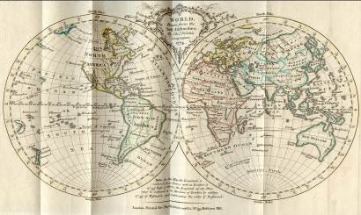
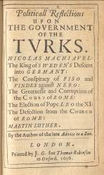

82 MAIR, John. A brief survey of the terraqueous globe: Containing, I. The description and use of the globes; II. The construction and use of maps; III. Geography, or a short view of the antient and modern state of several kingdoms of the world. Edinburgh: printed for John Bell and William Creech. 1775.
12mo. in sixes. viii, 350pp, 2 multi-folding colour maps. Contemporary full calf gilt, raised bands, red calf gilt label to spine, sprinkled leaf-edges. Minor wear to leather with small amount of loss to rear board; ink signatures to front/rear free and paste-down endpapers; vertical crease to half-title page; pages 161-164 slightly sprung; text lightly age-browned with some occasional minor foxing. £480
First published in 1762 (without the maps - as mentioned in the preface), published again in 1789. Both maps, by T. Kitchen, are coloured in a contemporary hand.
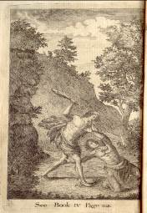
ESTC: L, E; MnU.

83 The death of Abel. In five books. Attempted from the German of Mr. Gessner. London: printed and sold by the Booksellers. 1770 8th Edition.
12mo. in sixes. xi[i], 167[1]pp, frontis. Contemporary full sprinkled calf with reback using old leather, original red calf gilt title label. Minor rubbing to leather extremes; text age-browned with some occasional soiling to pages; minor staining to lower margin of prelim pages. £80
Three American imprints are recorded for 1770 plus one by T. Thompson, London which is noted as false. Eighth editions are recorded at Dublin 1767, London 1772 (with the same imprint as here but different pagination), London 1766, Cork 1767. This imprint is not recorded.

1645 CLANDESTINE PRAYER BOOK.
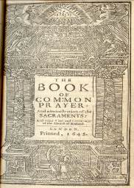
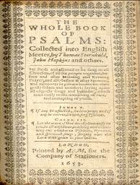

84 The book of common prayer: And administration of the sacraments: and other rites and ceremonies of the Church of England. London: printed by A.M. for the Company of Stationers. 1645. 12mo. in sixes. [92]pp, decorative title page. C7 has PSSLMS for PSALMS.
Wing B3614 - 3 copies.
Griffiths’ ‘Bibliography of the BCP’ page 106, stating the book is 8vo. ‘unusual collation and absence of ornament suggest clandestine origin of c1650.’ This was the last prayer book to be issued until 1659; on 13 March 1644/5 an Ordinance of Parliament had made its use a penal offence.
Bound with;
The whole book of psalms: collected into English Meeter by Thomas Sternhold, John Hopkins, and others. London: printed by A.M. for the Company of Stationers. 1653. 12mo. [64]pp, decorative title page. Wing B2450A - 6 copies.
Later reversed calf, marbled endpapers, all edges gilt. Minor wear/rubbing to leather extremes; small fractures along joints; ink notes to front flyleaf and rear free endpaper verso; text lightly age-browned and soiled with some minor occasional foxing; front hinge paper lifted from contents; staining to top-edge of pages throughout but no loss of text, a few leaves of the second work with lower margin shaved; some with what appear to be an ink stain - again no loss of text. £325
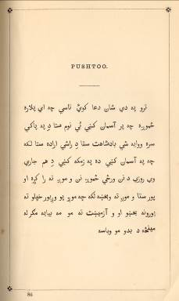
85 APOSTOLIDES, S. (Compiler) Our Lord’s Prayer in one hundred different languages. London: printed and published by W.M. Watts. N.D. [1869] 2nd Edition.
8vo. 8pp, 17-116 leaves printed on rectos only. Original blind-stamped purple cloth gilt, lettered to front board, all edges gilt, coloured endpapers. Minor wear/rubbing to cloth extremes; spine faded; neat spine head repair; text lightly age-browned with some minor marking to prelims. £125
With ‘opinions of the press’ loosely inserted; this was probably for the first edition since it is stated that the work was sold ‘for the benefit of the Cretan refugees in Greece,’ whereas this second edition [was] ‘published for the benefit of the “Brighton Museum of Hope”. This institution was founded by Miss Gordon for destitute female orphans and... supported by voluntary contributions’.
A scarce little work showing an extensive selection of William Mavor Watts’ exotic types, issued just prior to the fire in 1870 which destroyed his printing office. In the preface the author “embrace[s] this opportunity of thanking Mr. Watts, the Oriental Printer, for the assistance he has rendered me with regard to various types, &c,... he being the only one in England who could undertake the work, owing to its immense difficulties.”
COPAC: BL, Oxford. St. Bride catalogue 21535

AUTHOR’S OWN COPY, WITH ORIGINAL PHOTOGRAPHS.
86 A trip through Belgium with a party of English journalists. Alnwick: T. Graham. 1907.
22cm. 20pp, text illustrations, original printed orange card wraps bound in. Printed photograph of (presumably) the author to front paste-down endpaper, 14 tinted photographic plates, 90 plates in total. Photographs all laid down on card stubs and captioned in ink. Black half calf gilt, pebble grained black cloth sides, spine lettered direct, watered silk endpapers with free endpapers on card, hinges with linen reinforcement, all edges gilt. Minor rubbing to leather extremes; card stubs lightly age-browned with some foxing to gutter margins. £280
With all the original photographs except that facing page 10 which is not attributed to Graham, as are the others; this was probably a stock photograph. Graham accompanied a group of Northern journalists headed by Galloway Kyle, a significant contributor to the Northern Counties Magazine and editor of the Poetical Annual for 1909 ‘Garnered Grain.’ With a later printed endorsement by Graham informing readers that his copies of the Belgian tour and Belgian lecture had been gratefully received by King Albert.
Not in NSTC III. COPAC adds Newcastle.
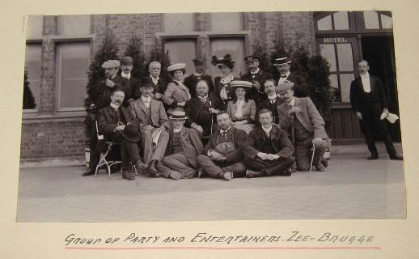

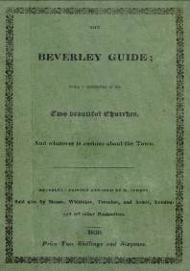
87 [TURNER, Matthew.] The Beverley guide; Being a description of the two beautiful churches, and whatever is curious about the town. Beverley: printed and sold by M. Turner; Also sold by Messrs. Whittaker, Treacher, and Arnot, London; and all other Booksellers. 1830.
12mo. in sixes. [iv], ii, 114pp, advert leaf, 7 woodcut plates, woodcut text illustrations. Original printed green paper boards, uncut, custom made matching printed slip-case. Minor wear/rubbing to board edges; small loss of paper to spine head; endpapers lightly age-browned. £150
Excellent example of original printed boards.
COPAC. York Minster. OCLC adds Newberry Library. Not in Boyne.

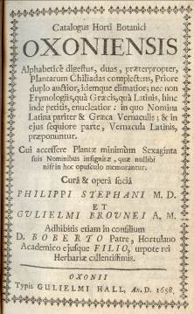
88 STEPHANI, Philippi; BROUNEI, Gulielmi. Catalogus Horti Botanici Oxoniensis. Alphabeticè digestus, duas, præterpropter, Plantarum Chiliadas complectensm Priore duplo auctior, idemque elimatior; nec non Etymologiis, quà Græcis, quà Latinis, hinc inde petitis, enucleatior: in quo Nomina Latina pariter and Græca Vernacula Latinis, præponuntur.
Cui accessere Plantæ minimùm Sexaginta suis Nominibus infignitæ, quæ nullibi nifr in hoc opusculo memorantur.
Adhibitis etiam in consilium D. Boberto Patre, Hortulano Academico ejusque filio, utpote rei Herbariæ callentissimis.
With, The second part of the catalogue of the trees and plants of the Physick garden in the University of Oxford. Oxonii [Oxford]: Gulielmi [William] Hall. 1658.
Small 8vo. [xvi] 48, 39-118, 129-187[1], [6], 193-214pp, double interleaved throughout, numerous contemporary notes to interleaving and margins of second part. Old hand-written blind-stamped calf, sprinkled leaf-edges, near contemporary hand written paper label to spine. Minor rubbing to board extremes and joints; water marks to front and rear boards; front and rear paste-down endpaper lifted from boards; text lightly age-browned with some occasional minor foxing. £650
Madan III, 2370; STC 1515; Not in Freeman.
ESTC general note - ‘Based largely on: Bobart, Jacob. Catalogue plantarum horti medici Oxoniensis.’

POX PAMPHLETS.

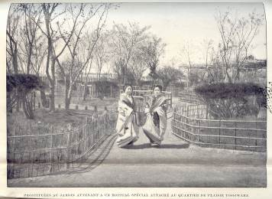
89 A wide-ranging collection of pamphlets in English, French and German, assembled for the 1899 International Medical Conference in Brussels. The conference focussed on the problems of venereal disease (particularly syphilis) and prostitution, with material relating to Norway, Italy, Japan, India, Romania and Mexico, as well as France, Germany and the UK. Its ethos was heavily influenced by what was termed the Abolitionist movement which set out to remove regulation and licensing of prostitutes. Many of the pieces are in original wraps or are proof copies and range in size between 4 and 78 pages. There are some statistical charts and maps, and one piece: ‘Prophylaxie de la Syphilis et des maladies veneriennes’ by Mokichi Morita contains five photographic plates of what is, in effect, the ‘red-light’ district of Tokyo. The contents preceded by a [4]pp manuscript index. Contemporary patterned maroon cloth gilt, contrasting calf-gilt spine labels, ticket of C. Cooper & Co., Ltd., Stationers, Birmingham to front paste down endpaper. From the Library of the Birmingham Medical Institute with ownership evidence to spine base and occasional internal ink-stamps. Front joint repaired; age-browning to text; some fragility to a few items due to poor quality paper. £380

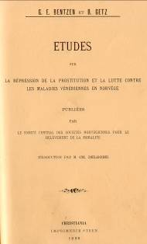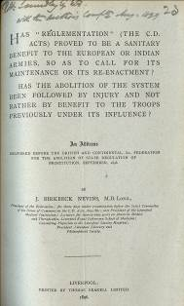
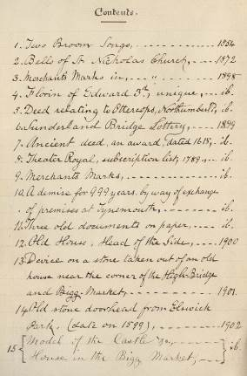
90 VENTRESS, John. Newcastle Interest. 15 items consisting of offprints, cuttings and a printed pamphlet. Principally:- Two broom songs of England. Newcastle-upon-Tyne: printed by W J Atkinson, 1854 [25 copies]. [ii] 3, [1], [4] pp, woodcut vignette to title page.
COPAC: Newcastle.
The Bells of St. Nicholas Church, Newcastle. Newscutting 1872, 2 columns, 4 excised illustrations with notes in Ventress’ hand, single ruled sheet of additional notes, signed J.V. 1892.
Old Home, Head of the Side, Newcastle. [Overprint from the Proceedings of the Soc. of Antiquaries of Newcastle-upon-Tyne, Vol ix, pp 314-316.], text illustrations, with 6 original wash drawings of the printed illustrations by J.V. with his ms notes in ink.
Proceedings of the Society of Antiquaries of Newcastle-upon-Tyne, Vol x, p 156 with the original ink sketch by J.V.
Other items include Merchant Marks in the Cathedral Church of St. Nicholas, 1898; The Sunderland Bridge Lottery 1899; and a 1789 Theatre Royal Subscription List, 1899.
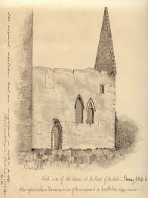
Early 20th Century half roan, matching cloth sides, printed paper spine label, ‘Miscellaneous Tracts relating to antiquities’, unpaginated. Item xv loose. The Author’s copy, signed by him on front free endpaper, additional notes and headings throughout. £270
From his entry in Anderton it appears that Ventress wrote nothing substantial. His main interest was assembling thematically related material. Four of these collections seem worthy of note, viz: The Castle of Newcastle; Bells; The River Tyne; Royal Visits to Newcastle. The BM Cat to 1956 records a single entry for him dated 1892.
A copy of fine local provenance with a note on the front paste-down endpaper ‘Lot 147 (part of). Purchased by me at Matthew Mackey’s sale 10 and 11 March 1920’ G.O.P. Gibson.

91 [HORN, Thomas] Limitation of the supply of grain by the past action of British Diplomacy. Report of the Sub-Committee of the Newcastle-Upon-Tyne Association for watching the war. Newcastle: Thomas Horn. 1855.
8vo. 22pp. Original printed pamplet, sewn, uncut. External pages lightly soiled with some age-browning and foxing; internally text lightly age-browned with some occasional minor foxing. £75
Horn’s career spanned the dates 1788?-1861. By 1855 selling stationery and music were his mainstays. Hunt quotes the Britannica traveller’s description of him - ‘a tolerable man with a marvellously small nose.’ Interestingly Horn was the Chairman of the Sub-Committee.
Much on Turkish affairs.
Similar item - London [1855] in NSTC with evidence supplied by David URQUHART.
This item specific to Newcastle is not located. Not found in Anderton.
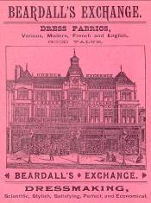
92 GREEN, John. Aberdeen to the muckle flugga. A tour through the Orkney and Shetland Isles. Sunderland: Herald & Daily Post General Printing Works. 1894.
18cm. 28pp, 2 fine adverts leaves printed on pink paper for Sunderland businesses, rear wrap in the form of an advert for the ‘Grand Hotel, Bridge Street, Sunderland.’ Original printed grey card wraps, stapled. Wraps lightly soiled & rubbed with small closed tears to spine tips & minor paper loss around staples; fore-edge of pages slightly creased; text lightly age-browned with the occasional spot of minor foxing. £45
Several institutional copies, but scarce in commerce.
Not in Arthur Mitchell’s ‘Tours of Scotland’.

93 OLIVER, Mr. J. Fencing familiarized: Or a new treatise on the art of small sword.
Illustrated by elegant engravings, representing all the different attitudes on which the principles and grace of the art depends; painted from life, and executed in the elegant and masterly manner. London: printed for John Bell. 1780 New Edition.
8vo. [iv], vii[vi], x-xlvii[i], 205[1]pp, text in English & French, with 14 plates as called for; 13 of them folding. Plate VIII was drawn by William Blake, Modern re-back with raised bands, retaining original calf sides, corners pasted and strengthened, modern red calf gilt label. Board edges rubbed with some minor loss of leather; sympathetic rear paper hinge repair; text lightly age-browned; minor worming to inner margin of prelims & final pages. £675
Thimm 211.
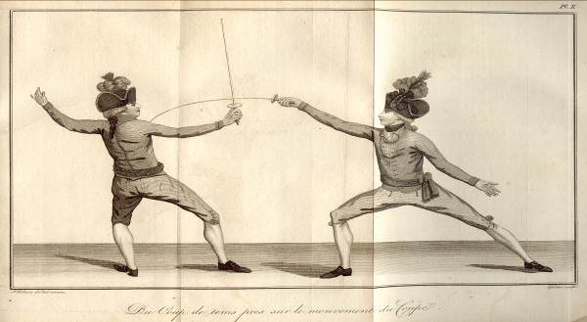

HOW TO DISPOSE OF THE MOTHER-IN-LAW
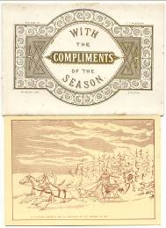
94 RICHARDSON, S.T. With the compliments of the season. Stockton: B.H. Heslop. c1880.
6 litho drawings measuring approx. 12 x 17cm. Original glazed card folder, lettered & decorated in gilt. Card folder lightly age-browned with heavy foxing internally; drawings in good clean condition. £75
A series of 6 litho drawings, post c1880 designed by S.T. Richardson.
His principal work was in the political field, particularly cartoons for the Stockton elections. In the early 1880’s he compiled ‘Splatterings of a Sporting Pen’, a collection of oblong folio lithographed sketches with descriptive letterpress. The jocular Christmas coaching prints offered here are typical of his output; they include one captioned ‘A Russian peasant’s way of disposing of his mother-in-law’.

DAVISON OF ALNWICK WOODCUTS
95 DAVISON, William. [Woodcuts] Alnwick: W. Davison, Bond Street. c1837.
A folded large folio sheet (567 x 450mm unfolded), printed on one side only, with eight groups of woodcut illustrations; each group within a decorative framed border.
Publishing details, together with a number indicating part of a series, are given below the border.
This sheet comprises: numbers 49: 52: 48: 5: 46: 54: 42: 65.
Paper lightly age-browned; small closed tears along folds & edges with some minor paper loss. £175
Many of the cuts can be found in Davison’s New Specimen Book (c1837); for example No. 48: The Oyster Catcher - no.550, The Hoxpoe no. 537; No. 42 - The Wild Boar no. 384, The Shepherd’s Day no. 380. Alternatively numbers 49 and 52 are taken directly from the half-penny chapbooks, and captions added.
Most unusual of this collection is No. 65 which is dominated by a large circular engraving of ‘The Clown’s visit to the Moon’, atypical in both size and subject matter.
These were probably sold to the juvenile market as full sheets or individual numbers at a premium.

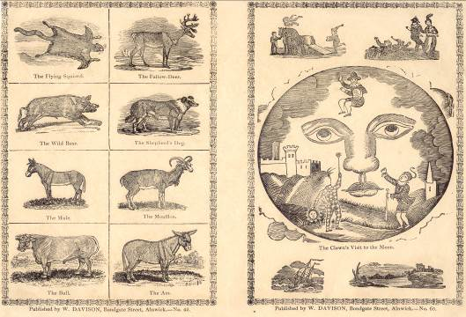
DAVISON OF ALWICK WOODCUTS
96 DAVISON, William. [Woodcuts] Alnwick: W. Davison, Bond Street. c1837.
A folded large folio sheet (564 x 451mm unfolded), printed on one side only, with eight groups of woodcut illustrations; each group within a decorative framed border.
Publishing details together with a number indicating part of a series are given below the border.
This sheet comprises: numbers 41: 11: 50: 33: 34: 38: 40: 35.
Paper lightly age-browned; small closed tears along folds and edges with some minor paper loss. £130
Many of the cuts can be found in Davison’s New Specimen Book (c1837), for example No 41 - The Lamp Fish no. 638; The Tarantula no. 701: No 11 - The Horned Owl no. 527, The Domestic Cock no. 561. Here, number 50 is taken directly from the half-penny chapbooks, and captions added.
These were probably sold to the juvenile market as full sheets or individual numbers at a premium.

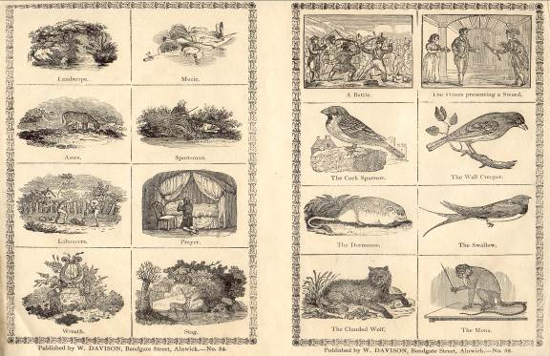

ORIGINAL MOSS SAMPLES
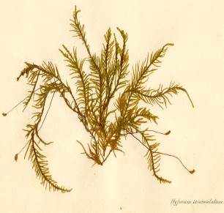
97 Mosses from Kincardineshire. Probably c1860.
Collection of 12 mosses mounted on thick card (215 x 155mm) with hand written ink title to each bottom corner. Comprises: Omalia trichomanoides; Bryum julaceum; Hypnum revolvens; Hypnum squarrosum; Hypnum purum; Dicranum majus; Hypnum loreum; Isothecium alopecurum; Hookeria lucens; Fissidens adiantoides; Neckera crispa; Hypnum commutatum. Held within a large envelope with hand written title & fern border. All samples have varying levels of worming, deterioration & loss; envelope age-browned with some water staining to edges and minor closed tears/ paper loss along folds. £65
From the Gladstone Library at Fasque.

CROQUET AT ILKLEY
98 [MACLEOD, William] The Ben-Rhydding book of gymnastics. Illustrated. Ilkley: John Shuttleworth. (c1865).
8vo. [iv], 86[2]pp, text illustrations. Original green cloth gilt, lettered to front board, binder’s ticket of Bone and Son to rear paste-down endpaper. Minor rubbing to cloth extremes; ink signature to front free endpaper; text lightly age-browned. £120
John Shuttleworth (1833-1909), was a prominent Ilkley bookseller and publisher. His main legacy to the town was a large collection of photographs of local interest; these are now housed in Bradford Libraries’ local studies collection. The book includes a final chapter on Croquet.
Not in COPAC. OCLC adds University of N. Carolina and BL (Wetherby). Not in Drazin.

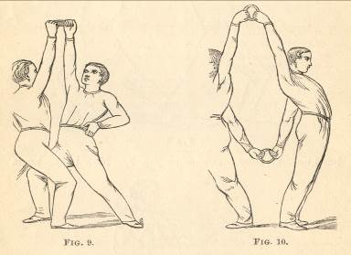
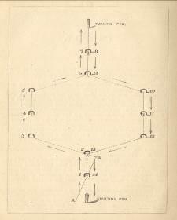

99 OLIVER, B.S. Companion to the almanac. For the years 1840-1848. Nottingham: B.S. Oliver.
18cm. 8 issues of the almanac companion bound together. 27[1], 36, 28, 31[1], 24, 22, 18, 20, 20pp. Later half maroon patterned-calf gilt, marbled paper sides, hand-written paper label to front board, later coloured endpapers, top-edge gilt otherwise uncut. Text lightly age-browned.
£260
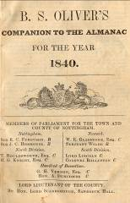
Oliver printed the ‘Strangers’ guide through Nottingham in 1848.
He was active in Long Row from 1840 to 1848 when his premises were taken over by Thomas Forman. His subsequent work at St. James’s Street, St. Mary’s Gate and Western Terrace, The Park, did not involve printing or publishing.
Not recorded in COPAC, OCLC, or BL Integrated Catalogue. Sole item in the latter, for Oliver as a printer, is an 1841 Race Card. Nothing further found in Nottingham University or City Library catalogues and just two items in COPAC: An address to the parishioners of St. Mary’s Nottingham 1842, and a medical essay 1848.
With the bookplate of the noted Nottinghamshire historian, bibliographer and book-collector, James Ward.

WITH A LETTER FROM SIR THOMAS PHILLIPS
100 WALCOTT, Mackenzie E.C. Church and conventual arrangement. With copious references, a complete glossary, and an index. And illustrated by a series of ground-plans and plates of the arrangements of churches in different countries and at successive periods, and of the conventual plans adopted by the various orders. London: Atchley & Co. c1860.
8vo. xvi, 222[2]pp, frontis, plates, additional letters, plates, plans tipped in & pasted down throughout. Contemporary red half calf gilt, raised bands, red cloth sides, top-edge gilt otherwise uncut, coloured leaf-edges, later endpapers. Ex-library with minor evidence (numbering to spine, ink stamp to title page & remnants of withdrawal slips to paste down endpapers); minor rubbing to leather & cloth extremes; text lightly age-browned. £600
With the fine bookplate of Frederick Hendriks F.S.S., F.L.A. Knight of Vasa, dated 1893. On the original front free endpaper verso he has added in pencil ‘Sold at Sothebys Nov 12 1909 to Thorp, Lot 477. I bought at 32/- Oct 1910’.
Extra-illustrated with a sepia drawing by Mackenzie, and over two dozen letters and other original plans and drawings by architects of the period including George Gwilt, Samuel Tymms, Lord Grimthorpe and John Adey Repton. The most significant of these additions is a fine 4pp ALS from Sir T[homas] Phillipps dated 18 Oct 1841 concerning his subscription to the ‘Round Church’, followed by details of ornamenting churches with paintings. Hendriks has added pencil notes to many of these items, as well as other pertinent notes to the text.
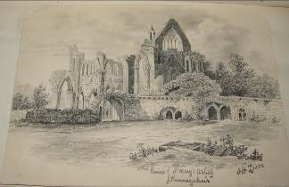
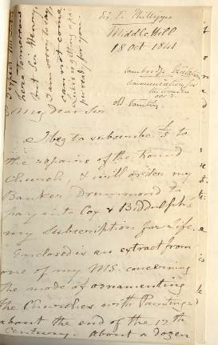

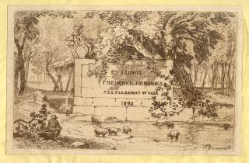
THE F

101 ANDERSON, Andrew. Observations on typhus: submitted to the faculty of physicians & surgeons of Glasgow. Glasgow: James Hedderwick & Son, 1840.
20cm. 66pp, text table. Disbound. James Douglas’s copy. £95
Detailed observations made at Glasgow Royal Infirmary during 1837/8. Anderson was awarded his M.D. at Glasgow University in 1839 at the age of 22.
COPAC: Aberdeen, Glasgow. An abridged edition was published in the same year.
See Bloomfield’s A Bibliography of Internal Medicine: Communicable Diseases pp 283-4, to realise that this was an early work on the subject; it followed that by Dr. Peebles in 1835.

102 M’TYER, William. Observations on the pathology and treatment of cancer: a probationary essay. Glasgow: printed by James Hedderwick and Son, 1829.
20cm. 21pp. Disbound. Very light isolated spotting. £65
The author received his Glasgow M.D. in 1826.
Unrecorded in COPAC and OCLC.

103 DOUGLAS, James. On phlebitis, particularly as connected with secondary abscesses; an essay submitted to the Faculty of Physicians and Surgeons of Glasgow ... Glasgow: printed by James Hedderwick and Son, 1835.
20cm. 48pp. Disbound. Very light isolated spotting. £60
Not in COPAC; OCLC adds University of Victoria, Australia.

104 CRAWFORD, John. Observations on the expediency of abolishing mechanical restraint in the treatment of the insane in lunatic asylums. A probationary essay submitted to the faculty of physicians & surgeons of Glasgow. Glasgow: printed by James Hedderwick and Son, 1842
20cm. 36pp. Disbound. Very light isolated spotting. £75
COPAC: Cambridge, Newcastle, Glasgow, NLS, Oxford.

LIVERPOOL. ROBINSONADE.
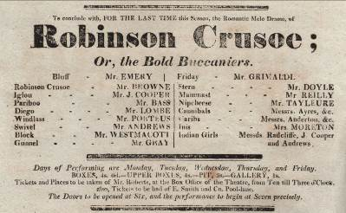
105 POCOCK, Isaac. Robinson Crusoe; or, the Bold Buccaniers.
Single sheet, 315 x 194mm. £110
An adaptation of Defoe’s novel. The play was first performed at the Theatre-Royal, Covent Garden in 1817 with Messrs.Emery and Grimaldi in their Liverpool roles.
Features a good cast of prominent early nineteenthe century actors - the principals in particular:
John Emery (1777-1822) of Sunderland was one of the leading comic actors of the period. His success was considerable, such that he was included in William Brockie’s ‘Sunderland Notables’ of 1894 with a 7pp entry.
Marie Rebecca Davison (1780?-1858) was born into an acting family and appeared on stage from an early age. She is recorded in both Dibdin and ODNB.
Joseph Grimaldi (1778-1837) was one of the most famous actors of the late Georgian period. His name has become synonymous with the role of the clown. Although the bill is for ‘Mr Grimaldi’s last Night but one’, brief details of the following day include ‘... Clown’s Dishes of all Sorts. Clown [-] Mr. Grimaldi’
Undated entries in COPAC choose [1822] for the Hodgson Juvenile edition with the exception of the Aberdeen University copy which is dated 1817 without brackets.

EXCEPTIONAL PANTOMIME PLAYBILL.
106 AN EXCEPTIONAL PANTOMIME PLAYBILL. [Among others] Comic Christmas pantomime, entitled, Three Legs, King of Man; ...
Single sheet, printed to one side only, 570 x 440mm. Folded. £260
This panto was founded on one of Roby’s ‘Traditions of Lancashire’.
Obviously much of Lancashire and Liverpool interest - mentions of Knowesley Hall, moving diorama of a voyage from Douglas ... to Liverpool, glimpse of Liverpool in 1800; additional reference made to ‘The Patent Railway Engine’ travelling at 70mph in 1852.
As ever ‘Children in arms not admitted’.
Cubbon, page 1029 ‘In the most interesting collection of playbills in the Museum is one which concerns a pantomime performed in Liverpool, in the Theatre Royal, Williamson Square, in January, 1853. Its title was ‘Three Legs, King of Man; or Harlequin, Lord Stanlie and the Eagle and Child.’ The words ‘Three Legs’ in the bill are formed of legs after the fashion of the Manx emblem, every stroke being a leg. The pantomime was founded on the legend of the Eagle and Child associated with the Stanley family. It was highly fantastic, and seems to have been very clever.’

107 THEATRE-ROYAL, Liverpool. This present Thursday, Oct. 1821, will be performed ... Poor Gentleman ... [and] The Grand Pageant of the Coronation of ... George the fourth ...
313 x 179mm. Playbill printed in black and sepia. £75
Although George IV’s extravagent coronation ceremony took place on 19 July1821, this playbill provides evidence that it was still a cause for celebration three months later. The playbill notes that the ‘Grand Pageant’ was taking place ‘for the 13th time at this Theatre’; indeed ‘more than one half of the town of Liverpool [had] been disappointed of places to see the CORONATION’.

ARGUMENTS AGAINST HALF-PRICE THEATRE ENTRY: RIOTS ENSUED! 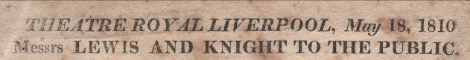

108 LEWIS, Wm. Thos.; Thos. KNIGHT. Theatre Royal, Liverpool, May 18, 1810. Messrs. Lewis and Knight to the public. Liverpool: printed by Wright and Cruikshank, 1810.
266 x 181mm. Broadside. Browned and spotted. £130
A cogent argument put forward by the joint managers of the Theatre Royal against demands for cheap tickets. Local theatre-goers compared prices in Liverpool and London and demanded that those in Liverpool should be reduced. Lewis and Knight, by examining the specifics at Covent Garden and the Haymarket, together with the take-up of day-to-day tickets, said that the reductions would not be economically viable. By September Lancaster Assizes were hosting ‘The King v Lemon and others’ with the press headline ‘Riots at Liverpool Theatre’. The Attorney-General acted for the prosecution; Baron Graham for the defence - no lack of commitment (and probably expense!) from either side. The outcome was that the defendants ‘were acquitted of the Conspiracy (by consent) and found Guilty of the Riot’.
BBTI gives the following: George Cruikshank (1809-1832) details state ‘Part Wright and Cruikshank 1804?-1807’; entry for Wright and Cruikshank gives dates 1804-17 in Castle Street. COPAC gives dates as 1806-[1817].

109 [YOSY, Ann.] Tales from Switzerland . London: Francis Westley and L B Seeley, 1822-23.
16cm. Various pagings, 2 plates. Contemporary half roan gilt, marbled boards. Bindings rubbed with slight wear; light spotting to prelims and last few leaves. £350
Ann Yosy, novelist, lived in London 1825-33, married a Swiss farmer. Remembered today for ‘Switzerland as now divided into nineteen cantons ...’ with its 50 hand-coloured costume plates (mentioned in Allibone) Generally seems to fly under the radar - no mention in Jane Todd’s Dictionary of Women Writers.
A collection of 11 works, of varying length; these include two in verse. The most extensive are Althun and Florine (Vol 2), and Egbert,or the House of Blessenburg (Vol 3). The firm of Francis Westley was associated with what may be termed ‘religious fiction’; the collection here is no exception. The short publisher’s catalogue at the end of volume 2 recommends the first volume as follows ‘Our readers may safely commit these Tales into the hands of their friends; we have read them ourselves with great pleasure, and should be happy if our limits allowed us to expatiate at length on their varied excellencies.’ -Christian Guardian, Dec. - no gothic horrors here.
COPAC: Aberdeen, 2 vols. (1822); NLS, 3 vols. (1822-3); Oxford, 2 vols. (1822-3). No mention of plates in any catalogue entry.
Not found in Halkett and Laing.
Garside, Raven & Schowerling 1822:12 noting the two plates. (SOLD)

NANSEN IN ORIGINAL WRAPS.

110 The Geographical Journal: Vol. XXX. No. 5 & 6. November & December, 1907. (2 Vols). [Including:] On North Polar Problems. By Dr. Fridtjof Nansen (Ilustrations, sketch-maps, and map); The Fan Mountains in the Duab of Turkestan. By W. Rickmer Rickmers (Illustrations) Dr. Stein’s Expedition in central Asia; The Valleys of the Himalayas. By R. D. Oldham; Western Sources of the Nile. By D. Comyn.On North Polar Problems. By Dr. Fridtjof Nansen (Section); Captain Percival’s Surveys in the Bahr El Ghazal Province (Sudan. Map showing the routes in Bahr El Ghazal Province, from prismatic compass traverses by Capt. C. Percival ... 1906-1907.); Surveys of the Mozambique Coast (Map); Travels in German, British, and Dutch New Guinea. By Rudolph Poch (Illustrations and sketch-map). An Exploration of the Mustagh Pass in the Karakoram Himalayas. By Aug. C. F. Ferber (Illustrations and sketch-map). London: The Royal Geographical Society, 1907.
25cm. xvi pp adverts, pp [469]-584, text illustrations, text maps, 2 mult-folding colour maps at rear.xvi pp adverts, pp [585]-743, viii pp title and index for the volume bound-in at rear, text illustrations and figures, 2 mult-folding colour maps at rear. Original blue paper wraps. £40
Fine colour litho advert bound into volume 6, with many further adverts (some on card) loosely inserted.
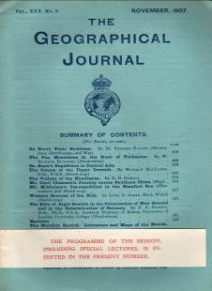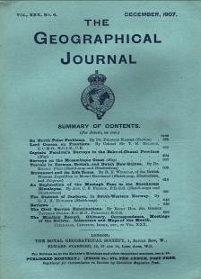

111 The Geographical Journal: Vol. XXX. No. 2. August, 1907. [Including:] From the Niger, by Lake Chad, to the Nile. By Boyd Alexander (Illustrations and map); A Journey from Yun-nan to Assam. By E. C. Young (Illustrations, diagram, and map); The heart of the Southern Alps, New Zealand. By James Mackintosh Bell (Illustrations and sketch-map). London: The Royal Geographical Society, 1907.
25cm. xvi pp adverts, pp [119]-236, text illustrations, 2 mult-folding colour maps at rear. Original blue-paper wraps. £20
112 WALLACE, Robin. Notes of pictures sold.
23cm. Unpaginated note-book alternating ruled sheets and cartridge-paper blanks. Linen-backed paper boards with well done illustrated title ‘Nature Note Book, E.S.A London.’ by Wallace to front board. Details of sales of artwork from c.1911 to 1921 - in which year 24 pictures had sold for a total of £155-0-4d. Turnover for Jan-Dec 1919 is listed as £171-17-1d.
Individual entries are revealing - “January 1920, Harry Hoggarth, Lowther Street, Kendal. Saturday Jan 10th. 1920. 1 watercolour drawing “Dawn” Leven Valley to Kendal exhibited at Lake District exhibition Keswick 1919, paid same day, half imperial, framed. 10.0.0”
The writer states on page 9 that entries to that point ‘are from memory. They are however fairly correct.’ £320
Robin Wallace (1897-1952) Cumbrian artist, born in Kendal. He studied at the Byam Shaw and Vicat Cole School of Art from 1918 to 1926; during this period (and before) his output was almost exclusively of the Lake District. After WWII he exhibited at the Royal Academy and had a one-man show at Colnaghi’s on March 12, 1952. His affinity with the Lakes remained throughout his life with his continuous membership of the Lakes Artist’s Society. (SOLD)

113 PIPER, Rev. H.H. An essay on the peculiarities of pronunciation and the dialect of Sheffield, and its neighbourhood. Read Oct. 1st, 1824, at the monthly meeting of the Sheffield Literary and Philosophical Society, and at the request of the Council, afterwards delivered as a public lecture, before the Society. Sheffield: printed by H.A. Bacon. 1824.
15cm. 24pp. Later blue card wraps, stab-sewn. Wraps lightly soiled with some minor wear/rubbing; small loss of card to spine tail; minor spotting to prelims; text lightly age-browned & soiled. £65
COPAC: Cambridge, Leeds, York Minster.
Skeat & Nodal’s ‘Bibliographical list of works...in various dialects of English’ page 129. This is the first work in the Sheffield dialect.
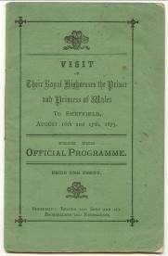
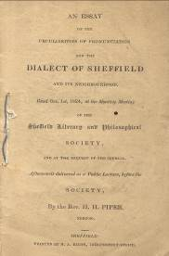
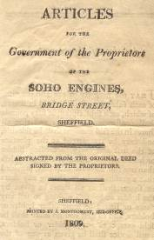

114 Articles for government of the proprietors of the Soho Engines, Bridge Street, Sheffield. Abstracted from the original deed signed by the proprietors. Sheffield: printed for J. Montgomery. 1809.
Wraps lightly soiled and foxed with spine torn; minor closed tear and paper loss to wrap-edges; text lightly age-browned, soiled and foxed; some creasing to pages. £180
115 Visit of their Royal Highnesses the Prince and Princess of Wales to Sheffield, August 16th and 17th, 1875. From the official programme. Shefffield: Leader and Sons. 1875.
16cm. 20pp, advert to rear wrap. Original printed green card wraps, sewn. Wraps lightly soiled and spotted; text lightly age-browned with additional spotting to prelims. £30
A similar item in COPAC at Leeds; the description indicates the covers here are different.
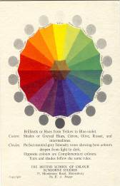
116 RAGGE, M[ary] A. The ABC of colour. A guide to immediate colour effects. Shrewsbury: British School of Colour. c1925.
150 x 110mm. Printed information sheet, colour-printed spectrum on stiff card, 3 limp card charts, held within original printed paper sleeve. Small closed tears, creasing & minor paper loss to sleeve. £35
An aid to choosing a colour-scheme, using adjacent and complementary colours viewed and mixed through holes in the charts, imposed where appropriate.
COPAC: BL, Edinburgh.

117 BIRKS, J.S & T. (Teamen, from London & Wine & Spirit Merchants). The Sheffield Almanac for 1877. Being the twenty-fourth presentation, with a list of articles, to their friends and customers. 1877.
13cm. 64pp, 5 plates. Original blue glazed card wraps, lettered in gilt, sewn. Wraps worn/rubbed to extremes with fading to gilt lettering; minor chipping to wrap edges with some minor card loss; text lightly age-browned. £50
This almanac, in effect a fine trade catalogue and price list for the publishers, concludes with a Birks’ wine and spirit section which includes 5 full-page woodcuts of various wine cellars; it is not to be confused with the more readily available Sheffield and Rotheram Almanac.
COPAC: Leeds. 1862, 1875, 1877 issues.
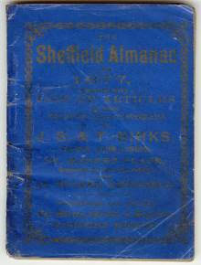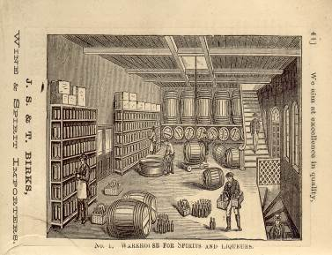

CARLISLE PRINTED BOOKS ON THE BIBLE
118 R, M. The books of the Bible. Carlisle: Sold by H. Scott & Sons. c1880.
Broadside 204 x 121mm. Text lightly age-browned; 2 horizontal creases. £45
The imprint is probably the long established Carlisle firm of H[udson] Scott.
Not in COPAC or OCLC.
A 55 line poem listing and commenting on the contents of the Bible from Genesis to Revelation.

119 Panorama of Sheffield. London: Rock & Co. 1849-1851.
Contains 12 views dated between 1849-1851. Original blind-stamped blue cloth gilt, coloured endpapers. Minor wear to cloth extremes; small fracture to front paper hinge; panoramas lightly soiled & age-browned. £75
A typical Rock panorama view-book with fine decorative borders to the plates.

TRIAL & EXECUTION OF THE POISONER WILLIAM PALMER
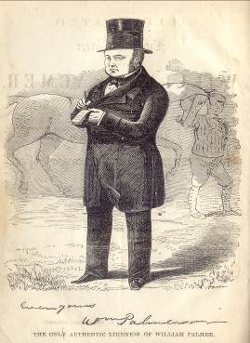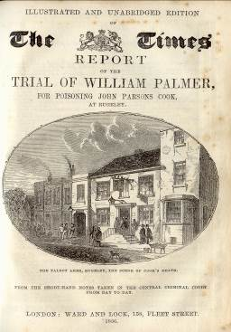

120 Spine faded with some minor cloth loss to spine tips; ink signature & date to front paste down endpaper; text lightly age-browned & foxed heavier to occasional pages; closed tear to multi-folding frontis. £195

GLASGOW COTTON-SPINNERS TRIAL
121 SWINTON, Archibald. Report of the trial of Thomas Hunter, Peter Hacket, Richard M’Neil, James Gibb and William M’Lean, operative cotton-spinners in Glasgow, before the High Court of Justiciary, at Edinburgh, on Wednesday, January 3, 1838, and seven following days. For the crimes of illegal conspiracy and murder; with an appendix of documents and relative proceedings. Edinburgh: Thomas Clark. 1836.
8vo. ix[i], 381[1]pp, xlvi, multi-folding plan. Original maroon cloth, original spine paper label, coloured endpapers, uncut/unopened. Cloth lightly spotted; spine faded with minor cloth loss to spine head; text lighly age-browned with some minor occasional foxing. £195
The appendix contains the whole Documentary Evidence, together with the speeches of Lords Medwyn and Cockburn, and Mr. Sheriff Alison, at Glasgow, on the subject of Trades Combinations.
The defendants were union leaders and brought to trial after a strike-breaker was murdered.
Goldsmiths 30601, Kress c4652.

TRIAL OF THOMAS MENZIES
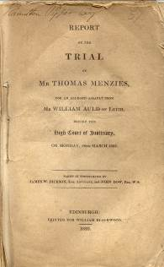
122 Report of the trial of Mr Thomas Menzies, for an alleged assault upon Mr William Auld of Leith, before the High Court of Justiciary, on Monday, 28th March 1825. Taken in short-hand by James W. Dickson, Esq. Advocate, and John Dow, Esq., W.S. Edinburgh: printed for William Blackwood. 1825.
8vo. iv, 132pp. Uncut, stab-sewn as issued. Ink signature to upper margin of title page; chipping/closed tears with some minor paper loss to leaf-edges; exposed pages heavily age-browned. £160
COPAC: NLS. OCLC adds numerous North American libraries with an electronic resource.

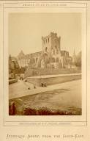
123 SMAIL, Thomas. Smail’s guide to Jedburgh and vicinity and angler’s guide to the Teviot and its tributaries. Jedburgh: Thomas Smail. 1871 2nd edition.
19cm. 72pp, with pages 53-70 mis-paginated [3]-20, [8]pp adverts with further adverts for Thomas Smail on both paste-down endpapers, real photo frontis plate. Original diced green cloth gilt, lettered to front board. Ink spots to front board; minor rubbing to spine-edges; minor foxing to prelims & final pages. £70
COPAC: BL, NLS. No 1st edition recorded.
Westwood & Satchell page 195, citing this edition; the 3rd & 4th editions also included the angler’s guide.
Coleby ‘Regional Angling Literature’ page 54 - the 1871 edition. Not in Gernsheim.

124 BURNETT, John. Nine hours’ movement. A history of the engineers’ strike in Newcastle and Gateshead. Newcastle-On-Tyne: printed and published by John W. Swanston; London: F. Pitman; Manchester: Tubbs & Brook. 1872.
21cm. 77[1]pp. Disbound, stab-sewn. Sympathetic paper strip to spine and spine-edges; minor paper loss/creasing to title page and fore-edges; prelims soiled; leaf-edges lightly foxed. £150
W.G. Armstrong among the contributors for the employers.
This was seen as a landmark in 19th Century industrial relations; engineers wanted to work a maximum of 9 hours per day and in effect reduce their working week from 59 to 54 hours. The end result was a victory for the strikers.
COPAC. Held as an electronic resource. OCLC lists 5 copies including 3 in the UK (Glasgow, Newcastle, and London Universities).

125 ZIMMERMAN, Johann. Historical and antiquarian sketches of the neighbourhood of Sheffield: Comprehending, within a distance of twnety miles. descriptions of buildings and natural scenery, biographical notices, traditions, and events of local interest.
Together with historical, antiquarian, and heraldic information. Beautifully illustrated by E.W. Andrews.
Vol. I. The Loxley and the Rivelin (all published). Sheffield: Pawson & Brailsford. 1863.
8vo. 64pp, frontis, long presentation inscription by the author to Mr. John Parley to frontis verso, plates. Contemporary full black calf gilt, all edges gilt, coloured endpapers. Signed binding by ‘Rodgers, Sheffield’. Minor rubbing to extremes; small closed tear to spine head; text lightly age-browned. £110
COPAC: BL, Leeds, Sheffield.

HISTORY OF SHEFFIELD.
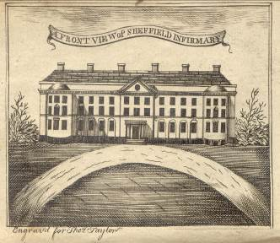
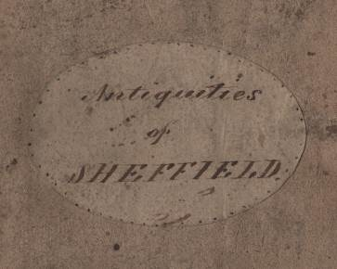

126 [TAYLOR, Thomas] The antiquities of Sheffield: Containing a description of Trinity Church, its monuments, &. Copy of the grants of Q. Mary and Lord Furnival, original agreement for building Lady’s Bridge; copy of William Birley’s will; siege of Sheffield Castle.
A brief description of the town and parish, wrote in 1774. Extent of the parish and surveys of its inhabitants. Antiquity of the cutlery manufactory. &.
To which is added a particular account of the ceremonies, procession and regulations observed in laying the first stone of the Sheffield General Infirmary, Part I (all published). Sheffield: printed for the compiler, Thomas Taylor. 1797.
12mo. in sixes. 53[1]pp, frontis. Modern quarter style russet cloth, cream paper boards, sprinkled leaf-edges, modern endpapers, tan skiver gilt title label, original front wrap with hand written label bound in. Front wrap soiled; text lightly age-browned. £480
‘Thomas Taylor (1745?-1819) was, according to W.T. Freemantle, the principal letter-carrier of Sheffield for more than thirty years.’
ESTC: L, O, SHp; Yc.
Enid Gilberthorpe ‘Books and Pamphlets printed in Sheffield before 1801’, 221.
ESTC does not give imprint and date whereas our copy, and Gilberthorpe’s (at Sheffield City Library) do.

127 GIBSIDE WINE ACCOUNTS. GIBSIDE WINE ACCOUNTS. A detailed inventory of wine stocks, together with some accounts, for the period May 23, 1744 - December 30, 1746.
4to. [45]pp in manuscript, blanks at rear. Modern linen-backed embossed-card wraps, title in green stamped to front wrap. Loosely inserted are the following manuscript summaries on seven sheets of varying sizes; a letter dated 1734 detailing a delivery of barley malt ‘for acct. of George Bowes ...’; an 1829 engraving of Gibside by Davison of Alnwick. £800
All details are given in a tabular format apart from resumés taken on June 2, 1744 and May 24, 1745. These appear at the rear of the volume and mention Mr. Seaton and Mr. Stephenson as regular suppliers with Mr. Robert Ellison and Mr. Van Hoff each delivering on a single occasion. All deliveries are noted and signed-off by C. Heron, presumable the Gibside cellarer.
In 1721 George Bowes, although the youngest son of Sir William and his wife Elizabeth (née Blakiston), inherited the Gibside and Streatlam estates. Until then Gibside had been rather the ‘poor relation’, but George embarked on a costly programme of development and restoration which was to last until his death in 1760.
Although covering only a two-year period this snapshot indicates that George was rather a ‘bon viveur’; his cellar contained upwards of 25 different wines and spirits and entries are listed on a daily basis. Generous consumption of red port wine, ‘London Clarett’ and Burgundy were part of the daily-round. Occasionally significant quantities are noted: August 1, 1744 ‘24 Red port in quarts, 12 White wine and 12 White port’ were despatched to Streatlam; September 1, 1744 ‘75 Port wine, 18 Port in pints, 120 Hock and 12 Burgundy’ were sent by cart to Ledstone Hall, near Castleford.
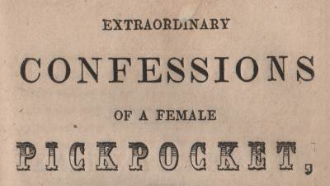
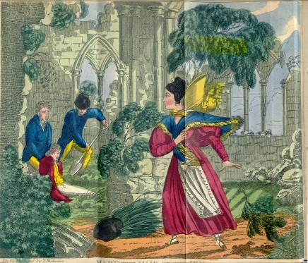
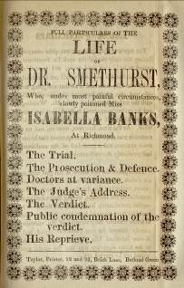
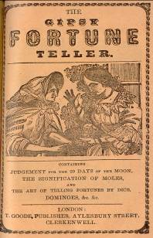
FEMALE PICKPOCKETS IN PRESTON, BOOK OF FATE, TRIAL OF DR SMETHURST
128 CHAP BOOKS.

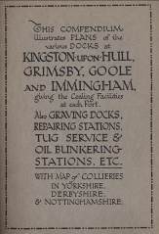
129 Plan of the River Humber. Shewing coaling stations, oil jetties, railways, etc., with map of collieries and railway connections. Hull: printed and published by Mason & Jackson, N.D.
45 x 65cm, panelled colour litho plan.
With: Compendium ... Published c.1925. 16cm. 3 folding maps, colour charts. Original grained-cloth gilt, compendium laid down to front inner wrap, plan tipped onto rear inner wrap. £95
Fine item.
Nothing in COPAC between 1904 and 1994.

130 TITANIC DISASTER. A concert (in aid of the sufferers) will be held in Victoria Hall, Helensburgh, to-morrow ... 25th April, ... Provost Ridston will preside ... N.P., [1912].
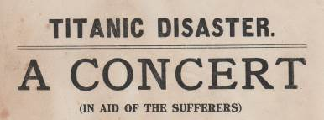
192 x 131mm. broadside. Very light spotting and browning to margin; closed tear to inner-margin not affecting text. £85
A small broadside advertising a relief concert ten days after the disaster. One of the numerous concerts to take place in the aftermath.

131 FREEMANTLE, W.T. Our local bibliography. A paper read at the Annual Conference of the Library Association, Sheffield University, 21st September, 1909. Aberdeen: The University Press. 1909.
24cm. 21[3]pp, author’s presentation inscription to Mrs. A. Sowerby to page 1, with a further note to title page verso stating ‘ I was limited to 40 minutes, but on giving a second time it was extended to 80 minutes’. Brown card sleeve cover with hand-written title by the author to front, uncut, sewn. Wraps lightly foxed; first page and rear endpaper foxed and age-browned. £40
This pre-dates Freemantle’s major contribution to Sheffield Bibliography by two years.
Not in COPAC.

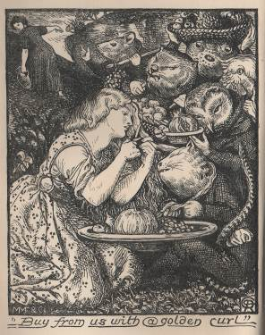
132 ROSSETTI, Christina. Goblin market and other poems. London & Cambridge: Macmillan & Co. 1862.
8vo. vii[i], 192pp, frontispiece with protective tissue guard and additional engraved title-page by D.G. Rossetti, 16pp publisher’s catalogue to rear. Original blue vertical ribbed cloth gilt, uncut, coloured endpapers. Minor rubbing to joints; small, almost imperceptible repair to spine head; ink date and 2 signatures to title page; prelims lightly foxed. £900
Rossetti’s first collection of poetry.
Ives A3.1. with page 26, line 17 in the second state (aguish not anguish). Binding A with greyish reddish brown endpapers and dated adverts - 1.7.62.
First issue with 16pp publisher’s catalogue at rear.

THE WONDERS OF CREOSOTE
133 DORMAN LONG & CO., LTD. Cresolution. Middlesborough: Dorman Long & Co., Ltd. [1931]
Pictorial thick folding card leaflet (25 x 11.5cm unfolded) advertising ‘Cresolution’ disinfectant, printed in black, orange & navy. Minor foxing to rear cover. £30

STRIKING FRONT COVER ARTWORK
134 ROSEDOWNS AND THOMPSON LTD., HULL. Modern old mill machinery. Leeds: Chorley & Pickersgill Ltd. N.D. [c1930’s]
All 4to. From 2pp to 16pp in length, illustrations throughout, printed on ‘art’ paper, various coloured bordering, comprises of lists No. 24, 32, 33, 38, 42, 45, 46, 48, 51, 49, 47b. Pictorial thick card wraps, yapp edges. Minor wear/rubbing to wrap extremes; bookplate to front wrap verso; hand written title to spine. £45
If nothing else, of value for the superb front cover.

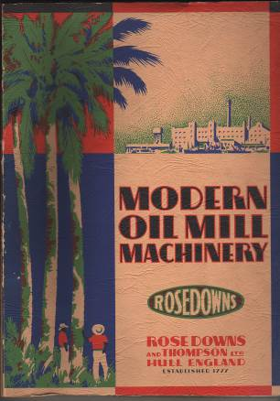
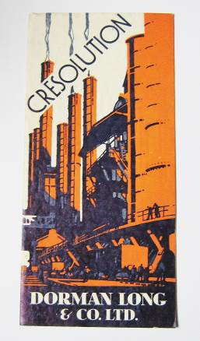

135 [HATFIELD, Charles William.] St. George's Church, Doncaster. Its destruction by fire; the rebuilding and opening; with an account of the erection and opening of St. James's Church. Doncaster: printed at the Gazette Office, [1854].
17cm. [2], 148pp, frontis, 2 further plates, text illustration; [4], 135pp, 2 plans; [2], [4], 52pp; pp [5]-214, plate. Original mauve grained-cloth, printed paper spine label. Spine and part of boards browned; front hinge-paper cracked but binding holding firm. £125
An inserted leaf, printed in red, follows the first two sections [A copy of the preceding pages was deposited in the chest of records placed beneath the foundation laid by his grace the archbishop of York.]
An altogether scarcer work than Jenkinson’s major history.
COPAC: York Minster, V & A (only 2 cuts). Not in Boyne.
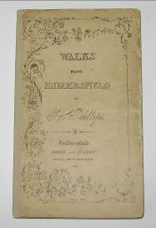
136 PHILLIPS, George Searle. Walks round Huddersfield. Huddersfield: Bond & Hardy. 1848.
8vo. iv, 91[1]pp. Original decorated printed limp paper boards, sympathetic re-spine using contemporary paper, protective quarter crushed morocco gilt slip-case, green cloth sides, spine lettered direct. Boards lightly soiled with some wear/rubbing to fore-edges; Skelmanthorpe library bookplate to front paste-down endpaper; text lightly age-browned. £150
G.S. Phillips also wrote under the pseudonym of January Searle. His output included works on Emerson, Wordsworth and Ebenezer Elliot, the corn law rhymer.
COPAC: York Minster. Boyne 134.

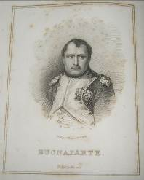
137 LASKEY, Captain J.C. A description of the series of medals struck at the National medal mint by order of Napoleon Bonaparte, commerating the most remarkable battles and events during his dynasty. London: Printed for H.R. Young. 1818.
4to. xiii[i], 239[1]pp, portrait frontis, vignette engravings. Contemporary fine full green pebble grained morroco gilt, raised bands, decorated compartments, decorative gilt border & floral urn to front & rear boards, all edges gilt, inner dentelles, patterned endpapers. Signed binding by J. Marston. Spine faded; minor rubbing to leather extremes; bookplate to front paste down endpaper; prelims lightly age-browned and foxed. £220
Extremely well-margined copy. A fine tall copy.

138 Monastic remains and ancient castles in England and Wales. Vol. I. Drawn on the spot by James Moore, Esq. F.A.S. and executed in aquatinta by G.J. Parkyns, Esq. London: Printed by George Stafford. 1792.
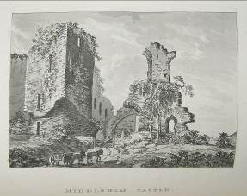
8vo. [vi] (title page, dedication, advertisements), 120pp, 60 plates, [2]pp index. Contemporary mottled calf gilt boards, later calf gilt spine, inner dentelles, marbled endpapers & leaf-edges. Surface leather loss to centre of front board; rubbing/wear to spine & extremes; small fracture to front & rear joints with some minor leather loss; bookplate to front paste down endpaper; minor foxing to prelims & final pages. £240
Vol I (all published) Not in Abbey. A much scarcer work that Parkyns ‘Monastical Baronial Remains’ (2 Vols 1816). Published the previous year (1791) with a note that the plates were ‘finished and etched by J. Schnebbelle’.

139 DAVIES, Benjamin R. Davies’ map of the environs of London. London: Edward Stanford, 1875.
1 hand-coloured map, dissected and backed with linen. 800 x 1110mm, folded to 200 x 140mm. Original blindstamped green grained-cloth gilt. £240
Published between 1855 and 1903; this edition not in COPAC (preceded by 1870; followed by 1876). See Hyde 39 (10) noting the change of address - first showing Liverpool Street Station.

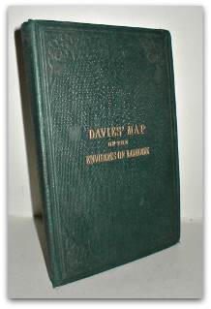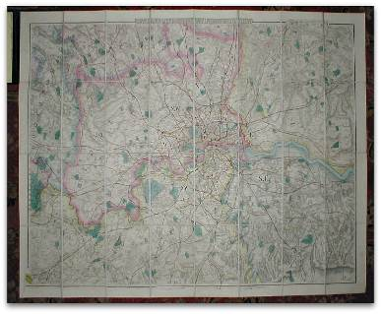

VICTORIAN ALBUM WITH ORIGINAL PROSE AND VERSE CONTRIBUTIONS
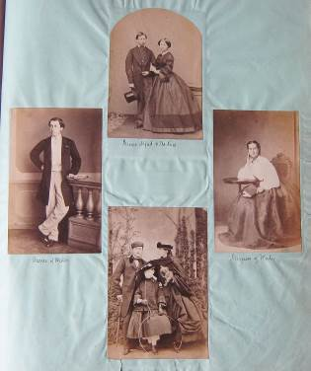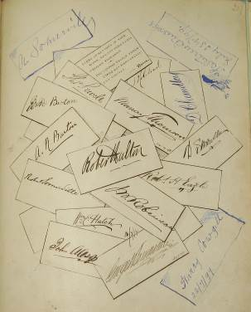

140 SOMERVILLE, George (Compiler)
25cm. Blank album of various coloured papers, manuscript pagination in ink to each top right corner, finishing with page 367 but with many leaves blank. Full green pebble grained calf gilt, raised bands, decorated compartments, highly decorated boards, marbled endpapers, all edges gilt, bookplate of George W. Somerville, Edinburgh, September 1866 to front paste-down endpaper. Minor wear/rubbing to leather; front joint cracked with board loosening; some foxing/soiling/age-browning to pages with some occassional tears/paper loss. £300
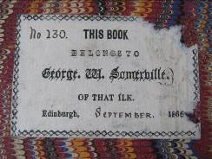
From the library of the minor Victorian Poet, George W. Somerville.
A typical Victorian Album containing cartes de visite, photographs, manuscript verse, topographical views, chromolithos and signatures; the whole prefaced by a manuscript index by Somerville. The cartes de visite range from a fine series by Mayall representing the Royal Family in extenso; national figures such as Wilkie Collins, Disraeli, and Palmerstone (sic); to those of parochial interest, many of whom have contributed to the album. These are complemented by assorted portraits of historical figures, possibly cut out from books. The Somerville family are captured pictorially - assorted photographs, and literally - verse contributions by George W. The latter are amongst 20 original pieces of verse and 3 pieces of prose (including ‘Beauty. Is it in the Mind or in the Object?’ by Jos. Simpson, Carlisle 1868). Contributors include published authors: George Chatt (Miscellaneous Poems, 1866), Peter Burn (at least six works in COPAC), Robert Eagle, John Dudgeon, John Pritchard and George Hinde are among the other twenty writers in the index.

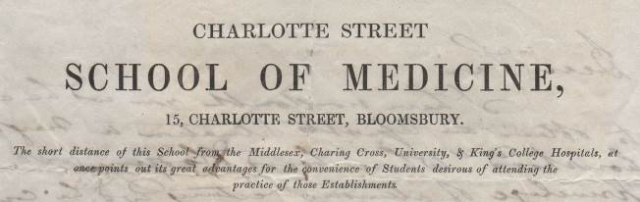
MEDICAL TRAINING FOR THE LESS WELL-OFF.

141 DERMOTT, George Derby. [Prospectus for] Charlotte Street School of Medicine, 15, Charlotte Street, Bloomsbury. [London: J Nichols, printer, 1844].
254mm. Single folded sheet, 4pp including first blank page. Folded for the post; closed tears and small pin-holes to some folds; inked amendments. £75
Also known as the Bedford Free Dispensary, the school was opened c.1820 by George Darby Dermott. Its low fees encouraged students from poorer backgrounds to take up the profession; this policy caused problems with the medical establishment, which considered such applicants unsuitable.
By December 1845 the school had removed to 28 Bedford Square; the prospectus here was probably the last to be issued from the Charlotte Street address.
With a long ALS by Dermott to the initial leaf blank recto - this dated Sept. 19th 1844 to an un-named recipient discussing regulations and fees. Additional notes and amendments to the contents are added by Dermott.
Nothing found in COPAC or Wellcome Library on-line. The closest we can find is the North London School of Medicine, Charlotte Street c.1840.

142 Blind Willie. From an original drawing by the artists. Newcastle Upon Tyne: W. Boag. N.D. (c1832)
Broadside 170 x 170mm, printed on India paper, text illustration. Text lightly age-browned with some minor spots of foxing; vertical crease & minor creasing to fore-edge. £60
This is the same likeness as the transfer print on a mug held at Tyne & Wear Museums. William Purvis (1752-1832), probably the most famous Newcastle eccentric and the central figure in Henry Perlee Parker’s group portrait of ‘Newcastle Eccentrics’ was remembered affectionately by the local poet Robert Gilchrist in ‘Blind Willie’s Epitaph’.

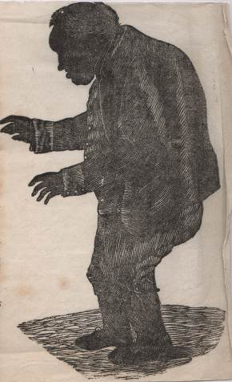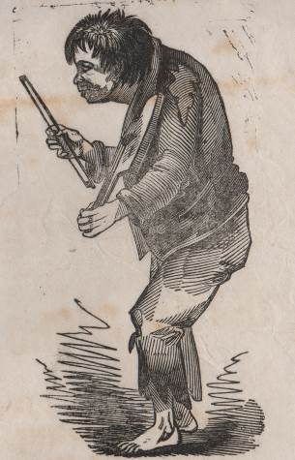

143 The life and melancholy death of Wm. Mc’Lacklan, alias Cuddy Willie. Who died by suffocation, from drinking a bottle of whiskey, on Monday last evening. No publisher. No printer. [1847]
Broadside 510 x 120mm, printed on India paper, text illustration, central horizontal fold. Text lightly age-browned with some minor spots of foxing; minor paper loss to edge of centre fold. £75
Not quite ‘Breretonesque’ in its production, but certainly a good rival: change of type faces, mis-spellings, typos, lack of punctuation - indeed, a worthy example of street literature.
The piece here gives the cause of death as a surfeit of whiskey; elsewhere the tipple is cited as brandy. In any event, death took place on September 27th, 1847.

144 WEST, J. Walter. Fulbeck, a Pastoral. With illustrations [+ script] by the author. London: H. Wilford Bell, printed by Bradbury, Agnew & Co., Ltd, London and Tonbridge. 1901.
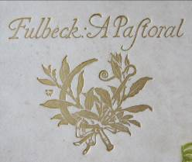
20cm. 21[1]pp, frontis, plates, text illustrations. Original parchment gilt boards, yapp edges, patterned endpapers, perishing/fraying green ribbon ties. Boards lightly soiled/spotted. £125
A superb association copy with notes by the author to the frontispiece and signed by him at the conclusion of the Pastoral. Complete with 5 lengthy ALS, 3 on notepaper with engraved headpieces by the author, all detailing aspects of the book’s contents.
Also included is a modern reprint with an accompanying letter to Capt. H. Fane, owner of Fulbeck Hall commenting on the history of Fulbeck and its relationship to this Pastoral.
Joseph Walter West RWS (1860-1933) was educated at St. John’s Wood Art School followed by the Royal Academy. Initially he painted landscapes and figures in both water-colours and oils but post 1907, landscapes, especially of France and Italy, were most prominent in his output. He was Vice-President of the RWS from 1918 to 1930 and died in 1933 at his home in Northwood, Middlesex.

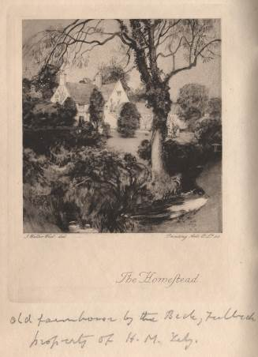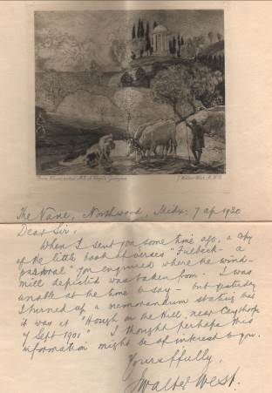

145 The Bombshell. Nos. 1-12 [inclusive] Vol. 3. January-December, 1919. [A monthly journal devoted to the interests of the employees of Thos. Firth & Sons, Norfolk Works, Sheffield.]
8vo. 487[1]pp, printed on ‘art’ paper, plates and illustrations within the pagination. Publisher’s maroon cloth gilt, floral endpapers, sprinkled leaf-edges. Light damp-staining and rippling to some upper margins. £90
Many items relating to WWI.
A three-part article relating to swimming and life saving, plus one on ‘Commercial Airships’.
The usual emphasis on sport and social activities.
Not in COPAC. BUCOP records vols. 1-16 (1917-1932) with Sheffield Public Library (the sole location) holding vols. 3-16.
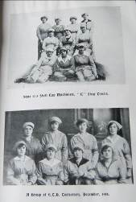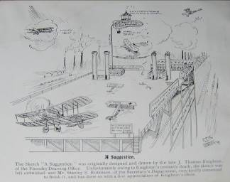
TAYLOR’S TRACTS WITH AN IMPECCABLE PROVENANCE
146 Tracts (chiefly rare & curious reprints) relating to Northamptonshire. 3 Vols. With illustrations. Northampton: Printed and published by Taylor & Son; London: Reeves & Turner. 1876.[vere 1892]
23cm. Vol 1: 26 papers with publisher’s catalogue, plates, text illustrations; Vol 2: 17 papers with publisher’s catalogue, plates, text illustrations; Vol 3: 12 papers with publisher’s catalogue, plates, text illustrations. Titles dated between 1866-1891. Contemporary blue half pebble grained morroco gilt, blue cloth sides, raised bands, decorated compartments, top edge gilt o/w uncut, marbled endpapers, signed binding by Birdsall of Northampton. Formerly in the Hesketh Library at Easton Neston, near Towcester. Minor rubbing to joints and extremes; minor discolouration to cloth; library location plates to front paste-down endpapers; minor foxing to occasional pages. £800
A fine set of Taylor’s Northampton Tracts re-issued by the publisher in bound volumes with general title-pages. The value of this association set is beyond reproach - 55 items in total including some of the scarcer titles. Taylor was one of the most assiduous provincial printers and publishers, especially in the field of local history. The practice of binding material together was a Taylor trait and his Antiquarian Memoranda and Antiquarian Gleanings contain similar (and often duplicated!) material.
The witchcraft tracts in Vol. 1 were republished during the 1970’s. Probably a special set bound for Lord Hesketh.
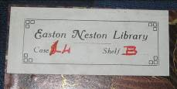
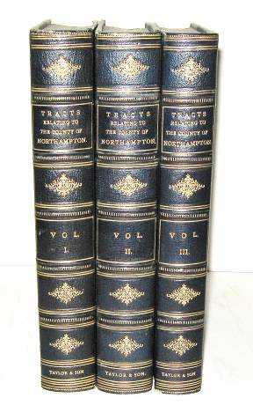
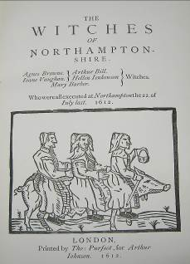

TAYLOR’S FAIRY RING IN ORIGINAL GLAZED BOARDS
147 TAYLOR, John Edward. The fairy ring: A new collection of popular tales, translated from the German of Jacob and Wilhelm Grimm. With twelve illustrations by Richard Doyle. London: John Murray. 1846.
8vo. viii[ii], 376[2]pp, 12 plates drawn by Richard Doyle, engraved by, inter alia, H. Vizetelly, G. Dalziel, and W.J. Linton, plates with protective tissue guards, 16pp publisher’s catalogue. Original printed blue glazed boards, uncut, coloured endpapers. Boards worn/rubbed; paper loss to spine head/joints/board-edges; gilt decoration to boards faded/discoloured; text lightly age-browned with heavy foxing to prelims and moderate foxing to plates. £600

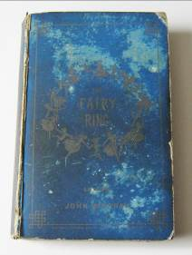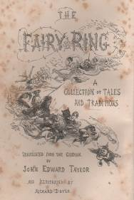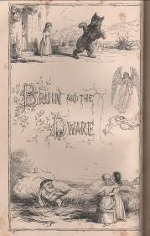

A pivotal work in the career of Richard Doyle - his work here established him within the field of fairy tale illustrations. Taken from the 5th edition of Grimm’s works, this 1846 offering contained a number of new translations: ‘The Hedghog and the hare’, ‘The Giant and the Tailor’, ‘The True Bride’ amongst them. Of more significance was the first appearance of ‘Rapunzel’, although he gave the heroine the name Violet. Although not in the best of condition, this copy does retain the original decorated printed glazed boards by Vizetelly; most copies coming to the market are rebound in calf or morocco.

SMAIL’S GUIDE JEDBURGH & VICINITY 1890
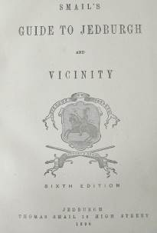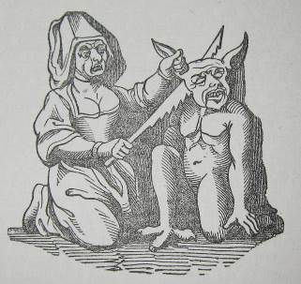

148 SMAIL, Thomas. Smail’s guide to Jedburgh and vicinity. Jedburgh: Thomas Smail. 1890 6th edition.
19cm. 69[3], title page with crest; 60pp; 49[1]pp. Original grey cloth, lettered in black to spine, coloured endpapers. Cloth soiled with some wear/rubbing to joints and extremes; ink signature to title-page; text lighlty age-browned. £85
From the copy at Newcastle in COPAC this combination of titles was published by Smail. The Newcastle copy comprises an 1852 5th edition Guide, an undated 2nd edition Worthies, and the 1874 autobiography. Our copy comprises an 1890 6th edition Guide, an undated 3rd edition enlarged Worthies, and the 1874 autobiography. The prelims to this 1890 edition of the guide are printed on inferior paper stock, and the fact that the concluding advert leaf states that the 2nd edition of Jethart Worthies is now ready indicates the work is a marriage.

FINE PUBLISHER’S BINDING TOGETHER WITH ILLUMINATED TITLE PAGE
149 BEMROSE & SON. Views of Risley, Derbyshire. Dedicated to J. Lewis Ffytche M.A.; F.S.A., Lord of the Manor. [1870?]
23cm. Elaborate illuminated title page, 11 chromolitho plates with decorative gold bordering & titles laid down on thick card, each with protective tissue guard. Contemporary full green morocco gilt, bevelled edges, decorated borders and gilt crest to both boards, all edges gilt, coloured endpapers. Signed binding by Bemrose, Derby. Minor leather loss to spine tips; pages & tissue guards age-browned and foxed. £280
COPAC: Nottingham [187-?], Cambridge [187-?], Oxford [Risley? 1868]. Not in NSTC or BL Catalogue.
Earliest Waddleton entry for Bemrose is 1875.
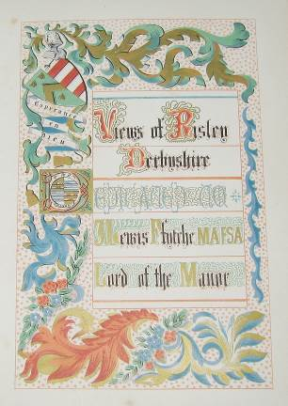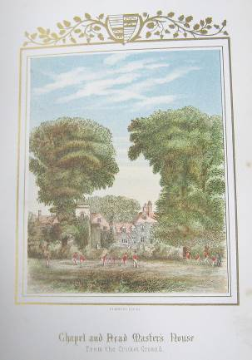

DURBAN LIGHT INFANTRY IN THE BOER WAR
150 Collection of manuscript copies of battalion orders. Feb 18th - May 14th, 1900.
Mostly in the same hand - Captain James Dick; some later ones by S. Molyneux. 1900.
28cm. Approx. 95 india paper sheets. Sheets stained, age-browned and foxed with some closed tears and minor paper loss to edges. £150
The DLI were active around the Mooi River (a small town close to Durban) from January 9th, 1900; they were posted to relieve the Dublin Fusiliers.
The less interesting sheets contain routine information for the day: duty officers, inspections, parades, drills, and the like; others go into more detail:- Natal Volunteers, promotions, discipline, Lord Roberts, and Ladysmith.
151 SHAW, Rev. John. Book-keeping epitomized: Or, a compendium of Mair’s methodical treatise of merchant-accompts, according to the Italian form; for the use of schools. Leeds: printed for J. Binns, J. Johnson, Oglivy and Speare; London: Vernon and Hood. 1794.
12mo. in sixes. 131[1]pp. Contemporary sprinkled full calf gilt, lacks label. Minor leather loss to spine and spine head; partial crack to front and rear joints with binding holding firm; ink signature & date to front free-endpaper & title page; text age-browned with occasional foxing. £350
John Shaw was appointed Head Master of Rochdale Grammar School in 1756 , he died in 1796. The relative scarcity of this work is demonstrated in the Manchester bookseller Albert Sutton’s [1913] Catalogue ‘Bibliotheca Lancastrensis’ (sic) where copies of 5 editions of Shaw’s ‘Methodical English Grammar’ were available at 1/- each, but no copies of this title were listed.
ESTC: L, Lica, LEp, E.
Historical Accounting Literature, page 85. An abridgement of John Mair’s ‘Book-keeping methodized’.

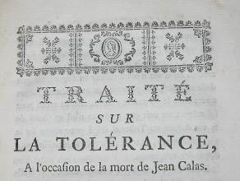
152 [VOLTAIRE, Francois Marie Arouet de]. Traité sur la tolérance. N.P. 1763 [Geneva 2nd edition].
8vo. iv, 183[1]pp. Contemporary full sprinkled calf gilt, gilt spine label, sprinkled leaf-edges. Minor wear to leather extremes; front joint cracked and rear joint partially cracked but binding holding firm; minor loss of leather to spine tips; text lightly age-browned, heavier to title page; minor damp staining to inner margin of final pages. £380
In terms of pagination the [2nd] edition most closely resembles our copy. Bibliotheque Nationale gives ‘In-8o, [11-]183pp (Bengesco n1693,2.) and adds the following note.
‘Nouvelle edition, faite a Genève d’après Bengesco, dans laquelle, le “N.B.” final est suprimé, mens la répouse a la lettre du 20 fevrier 1763, citée dans la demier chap. est augmentée de neuf paragraphes qui ne se retrouvent pas dans l’edition donnée par Voltaire dans les “Nouveaux Melanges” ’.

VOLTAIRE PRINTED IN GENEVA? MORE LIKELY LONDON.
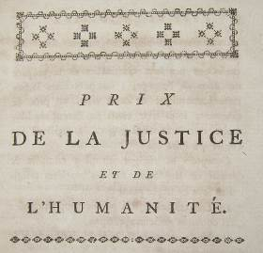
153 VOLTAIRE, M. de. Prix de la justice et de l’humanité. Genéve. 1778.
8vo. iv, 120pp. Near contemporary full tree calf gilt, black calf gilt spine label, sprinkled leaf-edges. Minor wear to leather extremes & joints; text lightly age-browned with some occasional minor foxing. £650
ESTC notes two editions of 1778: one with a London imprint, probably published in Switzerland, the other (the edition here) published in Geneva but almost certainly produced in London.
Voltaire, a champion against religious intolerance and judicial error; this a key work in that cause.
ESTC. L. only. ‘The imprint is false; possibly printed in London’. Bengesco 1874/3.
OCLC adds Kononklijke Bibliotheek (The Hague).

LONDON PRINTER SETS OUT HIS WARES.
154 [COGHLAN, J. P.] To the nobility. The utility of a printing-office has been often urged by the great, the learned, and the modest writer, ... [London]: J. P. Coghlan, printing-office, London, N.D.
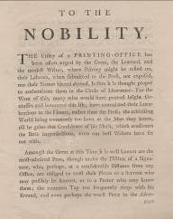
21cm. 3[1]pp. Drop-head title. Laid paper with horizontal chain-lines. £360
A fine bifolium addressing the set-up of a printing office by James Peter Coghlan of 37 Duke Street, London. Maxted gives Coghlan’s dates as c.1782-1800 and he is included as a letter-press printer in J. Pendred’s directory of 1785.
ESTC gives a date of [1790?] but the text suggests this was printed closer to when the business began - ‘The Types are new, and cast with the most-admired Beauties. And as I am sensible that Public Favours must be my sole Dependance, so by a steady Assiduity, I shall endeavour to deserve them.’
ESTC: L, MRc.

155 D[ODGSON], C[harles] L[utwidge]. The new belfry of Christ Church, Oxford. A monograph by D. C. L. Oxford: James Parker and Co, 1872 1st edition, 1st issue.
8vo. 23[1]pp, title-page device. Original printed wraps, sewn, within full red crushed-morocco gilt fold-over book-case, black calf gilt spine label. Small closed tear to upper margin of front wrap; slight creasing to wraps. £800
From the Gladstone library at Fasque and with the initials of Thomas Gladstone, 2nd Baronet (and elder brother of William) to the front wrap.
Written and owned by two alumni of Christ Church College, Oxford.
Green 71a. ‘This, the most amusing of the “Oxford Squibs” was reprinted in “The Lewis Carroll Picture Book” (1899).’
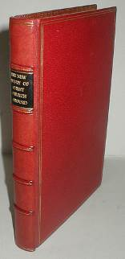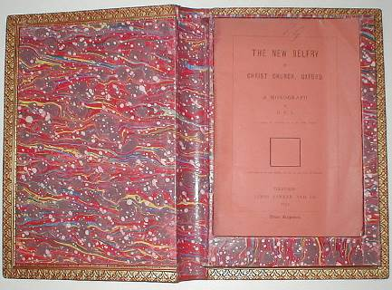

BALLOON TRIPS TO THE NORTH POLE
156 The Essex literary journal; or a monthly repository of literature, and the arts and sciences connected with the country. June, 1838, to May, 1839. Chelmsford: printed by Meggy and Chalk. 1839.
4to. [ii], 144pp, 2 plates, occasional text illustrations, publisher’s presentation inscription to upper margin of page [1]. Original brown diced cloth gilt, sympathetic repair to spine tips. Minor rubbing to cloth extremes; ink signature and notes to front paste down endpaper; text lightly age-browned. £160
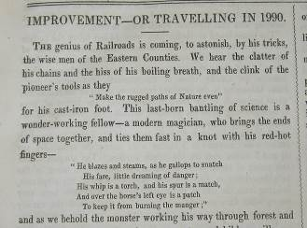
As expected much of local interest under general knowledge like Essex Worthies, Local Miscellany and Historical Sketches.
Also an interesting first article ‘Improvement - or travelling in 1990’ where the writer notes that ‘the Safety Balloon makes trips to and from the North Pole daily, with a touch at the Cape for passengers on its way home’.
Meggy and Chalk were prominent in the Essex booktrade for the first half of the nineteenth century.
COPAC: BL, ULRLS, Cambridge. 12 issues (all published).
BUCOP confirms issue dates as June 1838 to May 1839.

AUTOMATA IN LIVERPOOL INTRODUCE A NEW WORD TO THE ENGLISH LANGUAGE.
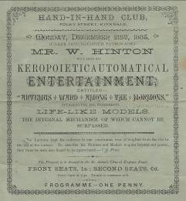
157 Mr. W. Hinton will give his keropoieticautomatical entertainment, entitled “Artemus Ward among the Mormons,” introducing his wonderful life-like models. The internal mechanism of which cannot be surpassed.
Folded advertising sheet 380 x 170mm (when extended) £125
The verso with a list of encomiums, a programme, and recommendations; all in the form of a spoof. “If this Entertainment is allowed to continue much longer, we shall be compelled to build a new wing” - Superintendent Rainhill Lunatic Asylum. The principal recommendation by IMWALLI NONTHI maintains that the writer’s wife ‘ill for over sixteen years ... got better at once [and] lifted a cottage piano quite a distance from the floor’.
In spite of all the, to some tastes, forced jocularity the performance itself appears genuine - Foley St., Kirkdale and St. Aidan’s were (and are) bricks and mortar. As to William Hinton - we have been unable to trace any other reference to him.

158 [BLAKE, Sir Francis] To the freeholders of the County of Northumberland. N.P. 1785.
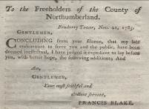
8vo. 12pp. Drop-head title. Printed pamphlet, stab-sewn, uncut. Title page lightly soiled and age-browned with ink spot to upper margin; vertical crease to centre. £300
Blake a law graduate from Cambridge, was High Sheriff of Northumberland during 1784 and 1785, the period that his main works, all relating to economics and finance, were written. These were printed collectively under the title ‘Political Tracts’, published in 1789 and again in 1795.
Blake’s concerns about tithe payments in Northumberland form the subject of the final third of the 1795 edition and reprint letters from Fowberry Tower dated Nov. 24, 1784 and Dec. 26, 1785. This Nov. 21 letter is not present; however careful textual examination indicates that Blake incorporated portions of the original tract into the collected edition.
The vast majority of recorded Northumberland freeholder material relates to the 1774 election - nothing found for this period.
Not in ESTC, OCLC or Kress.
159 Election for the borough of Newark. The poll book, taken before William Hilton, Esq., Mayor, June 9 and 10, 1826, alphabetically arranged, with the occupation and residence of each elector; and an analysis, exhibiting the number of plumpers and split votes given each day to the respective candidates. To which is added a complete collection of the addresses, hand bills, &c. issued prior to, during, and at the close of the contest. Newark: printed by Hage and Son, [1826].
8vo. 32pp, engraved crest to title-page.
COPAC: Oxford, Leicester Special Collections. Sims adds Newark Public Library and IHR. Not in OCLC.
Bound with;
Particulars of Newark election; containing the addresses, songs, squibs, &c. &c. circulated by the contending parties prior to, during, and at the close of the contest: together with an accurate list of the poll, taken before William Fillingham, Esq. Mayor, (systematically arranged in streests, &c. with the unpolled electors, and an analysis of the whole,) on Monday, Tuesday, Wednesday, Thursday, and Friday, the 2nd, 3rd, 4th, 5th, and 6th days of March, 1829. Candidates. Michael Sadler, Esq. Leeds. Thomas Wilde, Esq. (one of His Majesty's Serjeants at Law,) London. Newark: printed by Hage and Sons, [1829]. 8vo. [ii], 82; [ii], 8; 52, [4]pp, title-page printed in red and black & with engraved crest.
COPAC: Oxford, Leicester Special Collections. Sims adds Newark Public Library and IHR. Not in OCLC.
Bound with;
An alphabetical list of the poll, for the election of a representative, to serve in parliament for the borough of Newark upon Trent, taken before William Fillingham, Esq., Mayor, March 2, 3, 4, 5, & 6, 1829. Candidates: Michael Thomas Sadler, Esq. Thomas Wilde, Esq. Newark: printed and sold by Messrs. Ridge, [1829]. 8vo. 34pp.
COPAC: Oxford, Leicester Special Collections. Sims adds Newark Public Library and IHR. Not in OCLC.
Bound with;
A report of the speeches delivered at the hustings, and a reprint of the addresses, songs and squibs, issued by the different parties prior to and during the contested election for the Borough of Newark. Also an alphabetical list of the poll taken before William Readett Esq. Mayor on the 2d, 3d, 4th, 5th and 6th days of August, 1830 Candidates, Henry Willoughby Esq., Michael Thomas Sadler, Esq., Thomas Wilde Esq., Sargeant-at-Law. Newark: printed and published by S. and C. Ridge, 1830. 8vo. 126, 37[1], [6]pp, folding hand-coloured plate.
COPAC: BL, Oxford, Nottingham, Leicester Special Collections. Sims adds Newark Publc Library and IHR. Not in OCLC. This copy with 2 extra leaves not mentioned in the collations at BL and Nottingham.
Contemporary highly decorated full red calf gilt, raised bands, spine lettered direct, inner dentelles, marbled endpapers, two integral silk place-markers, all edges gilt. Leather worn/rubbed to extremes & joints; bookplate to front paste-down endpaper; text lightly age-browned with some occasional minor foxing, heavier to endpapers. £525
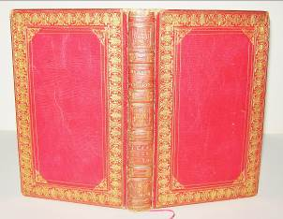
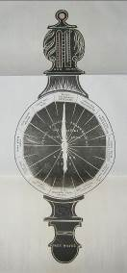
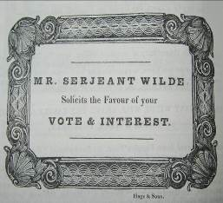

ISLE OF WIGHT FIREWORK DISPLAY PRINTED ON SILK
160 GIBSON, H. R.Y.S. Regatta programme of fireworks to be exhibited on the occasion of the Royal Yacht Squadron Regatta (by permission of the committee) on Thursday, Aug. 6, 1857, at Cowes, Isle of Wight. H. Gibson (Late Cannon) Artist in Fireworks, pyrotechnic for 37 years to the Royal Gardens, Vauxhall; the Corporation of the City of London: Engineer to the Fete in St. James’s Park, August 1, 1814; at the Coronation of His Majesty, Geo. IV, July 19, 1821; of His Majesty, William IV, June 10, 1831; and of Her Most Gracious Majesty, Queen Victoria, June 28, 1838. London: printed by J.W. Peel. [1857]
Advertising broadside printed on cream silk with light blue silk hem, 4250 x 2850mm. Currently under glass in a modern unattractive frame. A collection of 58 entries to form a complete display for the Royal Yacht Squadron Regatta. Minor wear to wooden frame; minor spotting/crease lines to the silk. £575
Taped to the frame backboard is a letter (from a previous owner), dated November 1984 offering to sell the item for £125, pencilled below this is the figure 150.
Peel worked exclusively as a printer. He seems to have been an itinerant - there are four locations for his business between 1822 and 1846 in BBTI; three of these in New Cut - the address here adds a fourth.
Can be posted without the frame if required.


